

Avaya™ Call Management System (CMS)
and CMS Supervisor

Sample Real-Time, Historical, and

Integrated Reports

Avaya™ Call Management System (CMS) and CMS Supervisor Sample Reports
Call Center reports are generated through the CMS Supervisor software. The CMS Supervisor software monitors the operations of and collects data from the DEFINITY switch. This data is then organized into reports that help you manage Call Center facilities and personnel. These reports may be displayed in real time, printed immediately, stored in a file, or scheduled for printing at a later time. The data tracked includes caller identification, service parameters, internal call transfers, outgoing calls, and agent sales.
Real-time reports can be updated as often as every three seconds and summarized as often as every 15 minutes. Historical reports are available in intervals of 15, 30, or 60 minutes; daily; weekly; and monthly summaries. Integrated reports include data for a specified start time in the past 24 hours up to and including the moment the report is generated.
One Avaya CMS can manage up to 10,000 agent/split/skill or agent/skill pairs in up to eight DEFINITY Automatic Call Distributors (ACDs) at different locations. This permits you to add agents in new locations while maintaining centralized supervision to control costs. You can use CMS reports to do the following:
- Determine how many agents are needed
- Manage call volume fluctuations
- Configure the software to make changes automatically and to meet unexpected demands
- Change agent skill assignments
- Move agents between skills and/or initiate agent audit trails.
- Change Vector Directory Numbers (VDNs) to vector associations.
The table below lists the CMS Supervisor reports that are available.

Report Name | Real-Time | Historical | Integrated
Agent Attendance |  | X
Agent AUX |  | X
Agent Event Count |  | X
Agent Graphical Information |  |  | X
Agent Graphical Time Spent |  | X
Agent Group Attendance |  | X
Agent Group AUX |  | X
Agent Group Summary |  | X
Agent Group Report | X
Agent Inbound/Outbound |  | X
Agent Information |  |  | X
Agent Login/Logout (Skill) |  | X
Agent Login/Logout (Split) |  | X
Agent Split/Skill |  | X
Agent Status by Location | X
Agent Summary |  | X
Agent Report | X
Agent Trace by Location |  | X
Busy Hour by Trunk Group |  | X
Busy Hour by VDN |  | X
Call Record |  | X
Call Work Code |  | X
Event Count Summary | X
Graphical Active Agents | X
Graphical Allocated Agents | X
Graphical AUX Reserve1 Agents | X
Graphical AUX Reserve2 Agents | X
Graphical Average Positions Staffed |  | X
Graphical Busy/Abandon/ Disconnect |  | X
Graphical Maximum Delay |  | X
Graphical Multi-ACD Service Level Daily |  | X
Graphical Queue | X
Graphical Split/Skill Call Profile | X
Graphical Staffing Profile | X
Graphical VDN Call Profile | X
VDN Call Handling |  |  | X
Graphical Skill Overload |  |  | X
Graphical Split/Skill View |  |  | X
Multi-ACD | X | X
Multi-ACD by Split/Skill |  | X
Multi-ACD Call Flow by VDN |  | X
Multi-ACD Top Agent | X
Outbound Split/Skill |  | X
Queue/Agent Status | X
Queue/Top Agent Status | X
Queue/Agent Summary | X
Reserve1 AUX Agents | X
Reserve2 AUX Agents |  | X
Skill AUX Report | X
Skill Status | X
Skill Top Agent Report | X
Split Status | X
Split/Skill Report | X | X
Split/Skill Average Speed of Answer |  | X
Split/Skill by Location | X
Split/Skill Call Profile | X | X
Split/Skill Comparison |  |  | X
Split/Skill Graphical AUX Agents | X
Split/Skill Graphical AUX Top Agents | X
Split/Skill Graphical Call Profile | X | X
Split/Skill Graphical EWT | X
Split/Skill Graphical Service Level |  | X
Split/Skill Graphical Status | X
Split/Skill Graphical Time Spent |  | X
Split/Skill Graphical Top Skill Status | X
Split/Skill Outbound |  | X
Split/Skill Queue | X
Split/Skill Service Level |  | X
Split/Skill Status |  | X
Split/Skill Summary |  | X
System |  | X
System Multi-ACD |  | X
System Multi-ACD by Split/Skill |  | X
Top Agent Status | X
Trunk |  | X
Trunk Group | X | X
Graphical Split/Skill | X
Trunk Group Summary |  | X
VDN Multi-ACD Flow |  | X
VDN Report | X | X
VDN Call Profile | X | X
VDN Service Level |  | X
VDN Skill Preference | X | X
Vector | X | X
Work State Report for Reserve1 Agents | X
Work State Report for Reserve2 Agents | X

Real Time Reports
CMS Supervisor real-time reports give a “snapshot” of the call center’s performance and status. For example, abandoned calls can be monitored to determine the waiting-for-service tolerance of callers and compared to the number of calls in queue. Standard real-time reports show the current status of ACD activity. The types of data for reports are status, cumulative, and administrative. Real time reports display data for the current interval for agent, split/skill, trunk/trunk group, vector, and VDN activities, such as number of ACD calls, abandoned calls, average talk time, and so on. All database items and calculations used for real-time reports are taken from the current interval tables.
The following diagram shows how the Real-Time reporting system is structured.

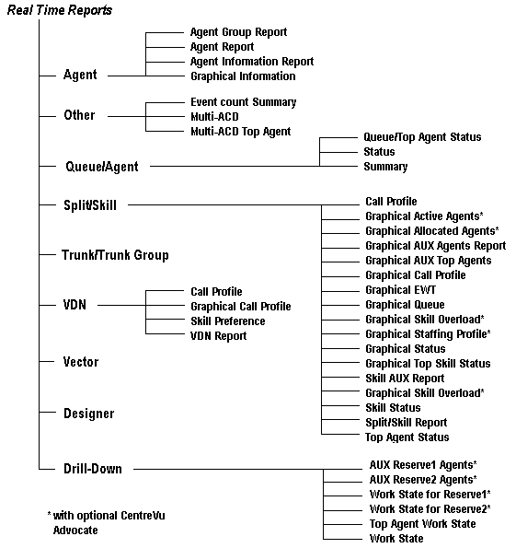

Real Time Agent Reports
The real time Agent reports give you the following specific information about agents:
- The agents according to groups you have created in the Dictionary subsystem.
- The current activities of all agents assigned to a split or skill.
- Real-time information and statistics for a specified agent.

Agent Group Report
The Agent Group Report allows you to view agents according to groups you have created in the Dictionary subsystem. For example, these groups could be new agents, agents with specific extension numbers, or any grouping that fits your call center’s needs.

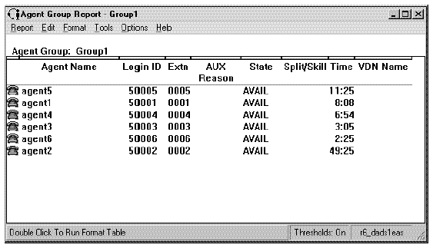

Agent Report
The Agent report displays the current activities of all agents assigned to a split or skill. It shows the extension from which the agent logged in, the agent’s work state, how long the agent has been in that work state, and the split or skill in which the agent is currently working. This report also gives you VDN information (if you have the Vectoring feature).

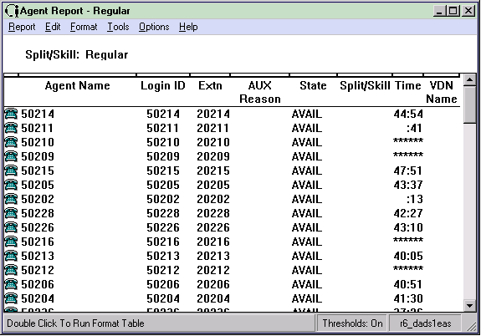

Agent Information Report
The Agent Information report displays real-time information and statistics for the specified agent. This version of the Agent Information report is for non-EAS users. This report includes a table that shows all the splits which the agent is logged into. If the agent is assigned to additional splits, but is not logged into those splits, these will not be reflected in this table.

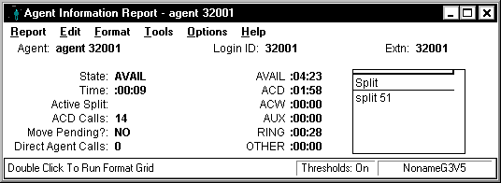

Graphical Information Report
The Graphical Information report displays real-time information and statistics for the specified agent. Supervisors can use this report to access further information on one particular agent without having to execute several steps and several different reports to get the pertinent information. This report enables the supervisor to quickly make a more educated decision on whether an agent should be added to or removed from a skill. You can access this report from the Real-Time Agent Category selector menu or by drilling down to this report from the Agent Name or Login ID fields on other reports (for example, Agent Information, Work State, or Graphic AUX Agent reports).
The report includes the following:
- Graphical information: A three-dimensional vertical bar chart, with time (in minutes)along the y-axis, and agent work states along the x-axis. The chart shows how much time (in minutes) during the current interval the agent spent in each of the work states.
- Table information: A table shows the skill that is assigned to the agent, and the skill level of 1-16
- A scroll bar is displayed if the number of skills to which the agent is assigned exceeds what can be displayed in the table.
- Real-Time report status

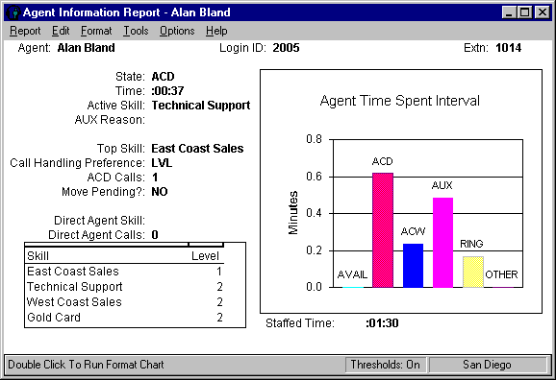

Real Time Other Reports
The Real-Time Other reports give you the following specific information about:
- A summary of the number of times during the current interval that an agent in a split/skill pressed any of the nine event count keys while on an ACD call or in call-related after call work.
- Real-time call-handling information.
- Skill information for skills from multiple ACDs.

Event Count Summary
The Event Count Summary report displays the number of times during the current interval that an agent in a split/skill pressed any of the nine event count keys while on an ACD call or in call-related After Call Work. You can define event keys to represent any kind of event you want (for example, the number of calls generated from an advertisement, promotion, or geographic area). Event counts are only recorded while an agent is on an ACD call or in call-related ACW. If an agent is in AUTO-IN mode, the ACD call terminates when the caller hangs up, and an event count cannot be recorded after the caller hangs up. To track event counts, it is recommended that agents use the MANUAL-IN mode because the agent goes to ACW when the caller hangs up, allowing the agent to enter an event count.
Event 0 is reserved for audio difficulty, is used in the trunk and trunk group exception reports.

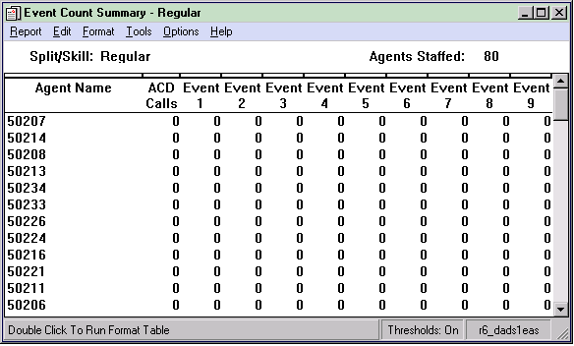

Multi-ACD Report
This report displays real-time call-handling information. This information can be requested simultaneously for up to eight splits/skills and up to eight ACDs. This report allows you to evaluate and compare similar splits/skill information in different ACDs. With this information you can determine workload and call-handling performance, agent reassignment, or other ACD configuration alternatives to balance workloads and reduce abandoned calls

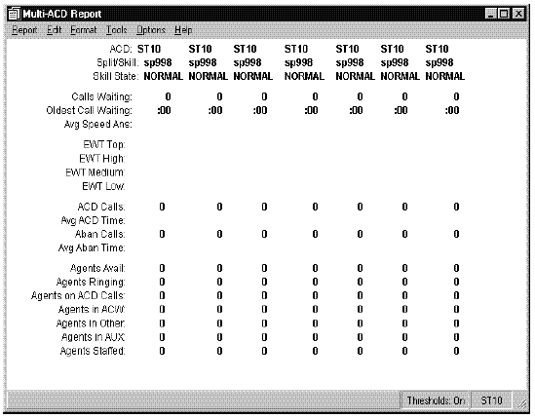

Multi-ACD Top Agent Report
This report displays skill information for skills from multiple ACDs. Agent counts show top and backup agents. This report allows you to enter skills from multiple ACDs connected to the CMS. The Multi-ACD report appears on the real-time reports menu even if you have only one real ACD installed on your Avaya CMS.
This report shows the number of agents with this skill as their top skill for DEFINITY ECS with EAS. This report shows the number of agents with this split as OLDEST_LOGON for non-EAS switches. "Top Agents" are agents for whom the skill is their highest-level skill. If agents have more than one skill at the highest level, then the first one administered is the top skill.

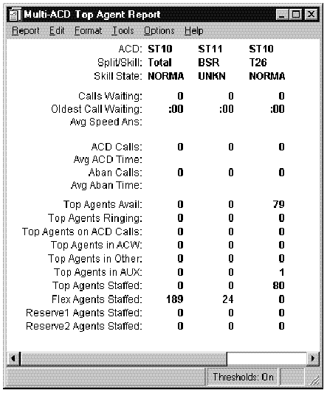

Real Time Queue/Agent Reports
The Queue/Agent reports give you the following specific information about Queues and Agents:
- The overall skill information along with information about agents for whom the requested skill is the top skill.
- The overall split/skill information such as the number of calls waiting, oldest call waiting, and percent answered within service level.
- A summary of the split’s/skill’s queue status.

Queue/Top Agent Status
This report displays overall skill information along with information about agents for whom the requested skill is the top skill. This report resembles the Queue/Agent Status report, but this report also displays the number of top agents staffed, available, ringing, on ACD calls, in ACW, in AUX, and in Other, plus the number of flex agents staffed. The number of calls answered and abandoned also appear on the report. "Top Agents" are agents for whom the skill is their highest-level skill. If agents have more than one skill at the highest level, then the first one administered is the top skill.

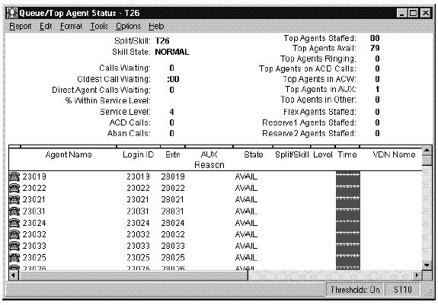

Queue/Agent Status Report
This report is a combination of the Agent report and the Queue/Agent Summary report. It displays overall split/skill information such as the number of calls waiting, oldest call waiting, and percent answered within service level. It also shows the number of agents available, on ACD calls, staffed, with calls ringing, and on after call work. It also shows what each agent in the split/skill is currently doing.

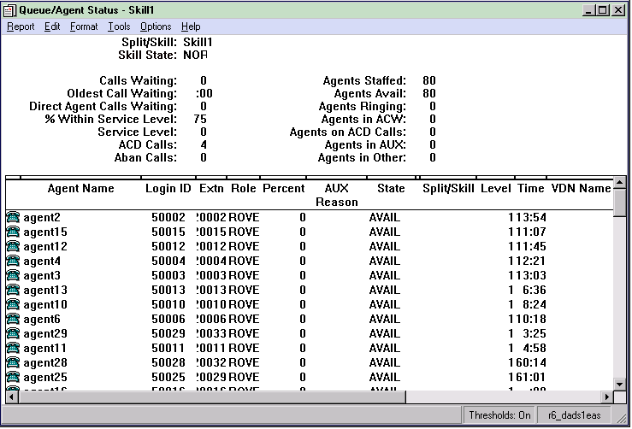

Queue/Agent Summary Report
This report summarizes the split’s/skill’s queue status (for example, how many calls are waiting in queue). It also summarizes the status of all agents (for example, how many agents are currently staffed or in after call work for the split or skill).

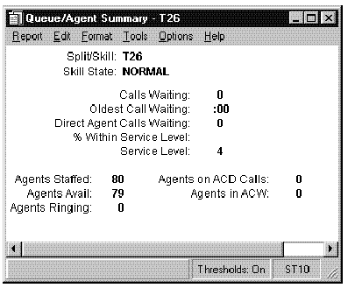

Real Time Split/Skill Reports

Split/Skill Agent Status by Location
This report shows the agent status on a selected skill, by location ID. This report supports the agent site tracking feature, and this feature must be enabled to view meaningful data on the report. This report shows information for agents in this skill by their terminal location ID. This report includes information on agent roles, skill state, agent extensions, location IDs, and skill level or percent allocation per agent. You must have a Generic 3 switch with the EAS feature.

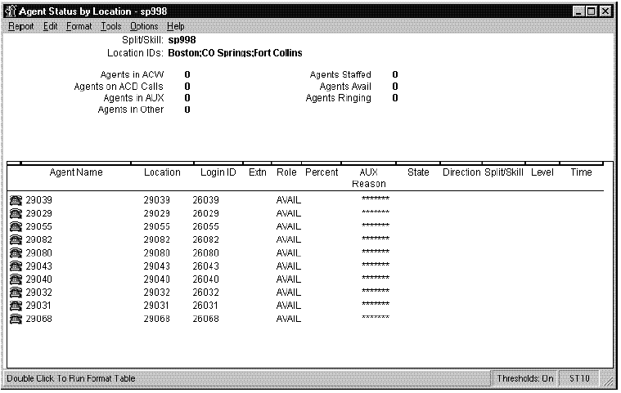

Split/Skill Call Profile
This report shows the wait times of incoming calls that are answered and abandoned in a split or skill during the current interval. Calls are displayed in ten columns, with each column representing a progressively longer wait time (increment). You must have administered service level and wait time increments for this report to be meaningful.

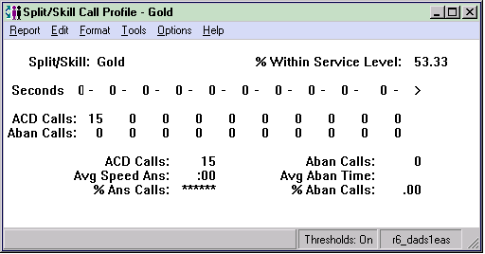

Graphical Active Agents Report
This report, which is available only for customers who have DEFINITY ECS R6 or later switches with EAS and have purchased Avaya™ Business Advocate, displays how many agents of different types are active for a selected skill. If Business Advocate is not activated, the fields of the report which pertain to Advocate will not be populated. Call center supervisors can use this report to see the number of Top, Flex, Reserve1, and Reserve2 agents staffed. The supervisor will also be able to see the number of each of those categories of agents who are active for the skill.
This report consists of two charts, as well as individual data items and field labels. This report has a two-dimensional bar chart with the following information:
- The title of the chart is “Top Agents Active,” and is centered above the bar chart.
- The x-axis contains the labels, “This Skill” and “Other Skills,” while the y-axis shows the number of agents.
The three-dimensional pie chart contains the following information for the number of agents active for the specified skill:
- The title of the chart is “Active Agents for xxx,” where xxx is the specified skill, and is centered above the pie chart.
- The pie chart's legend will be displayed by default, and shows Top, Flex, Reserve1, and Reserve2 agents.
- The number of agents for each category are displayed.

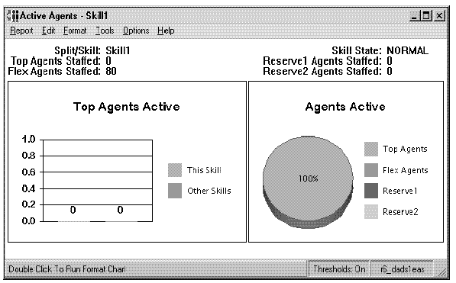

Graphical Allocated Agents Report
This report, which is available only for customers who have DEFINITY ECS R6 or later switches with Expert Agent Selection (EAS) and have purchased Avaya™ Business Advocate, displays the number of active and staffed percent allocation agents who are staffing a selected skill. If Business Advocate is not activated, the fields of the report which pertain to Advocate will not be populated.
You can access this report from the Real-Time Split/Skill Category selector menu. The Graphical Allocated Agents report will show the total number of active agents and full-time equivalent agents, for a selected skill. This report will also show the number of Standard, Reserve1, and Reserve2 agents staffed and the number of each of those categories of agents who are active for the skill. The Call Center manager or supervisor can use this report to determine how many agents are active from each agent pool and compare that to the number of total staffed agents.
This report shows the following two-dimensional bar charts:
- The chart on the left side of the report displays the agents active for the specified skill, and has a bar for the number of standard agents active, a bar for the number of reserve1 agents active and a bar for the number of reserve 2 agents active.
- The chart on the right side of the report displays staffed agents and has a bar each for the number of standard agents staffed, number of reserve1 agents staffed, and number of reserve2 agents staffed.

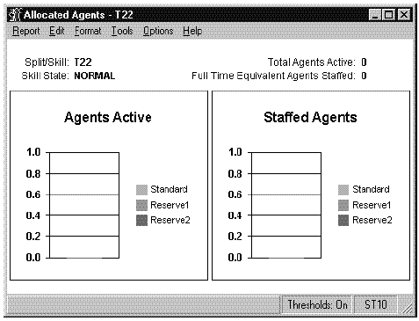

Graphical AUX Agents
This report shows all agents with this skill who are in AUX, the reason, and the time in AUX. You can access this report in the following ways:
- From the Real-Time Split/Skill Category selector menu.
- By drilling down from the AUX work state fields on other reports to this report. All other switch/ EAS configuration drills down to the Work State Report.
This report shows the following two-dimensional pie chart information for the number of agents in AUX for each reason code for that skill:
- The pie chart’s legend shows the synonym for each reason code and its corresponding color of the pie.
- The legend is sorted in ascending order by the reason code number, with the customer-defined synonym for reason code 0 at the bottom.
- The number of agents are shown inside each slice of the pie. This report includes the following table information:
- A row for each agent currently in the AUX work state for that skill.
- The agent’s name, login ID, reason code, and the time in AUX since the agent entered AUX for that reason code.
- You can specify how you want to sort the agent’s name, login ID, reason code, and time.
- You can use the scroll bar to see additional agents who are in the AUX state.
- Call center supervisors can use this report to see which staffed agents are unavailable to take calls, and for what reason. The supervisor can also see how long each agent has been unavailable for each of the reason codes. This will help show the supervisor who can be pulled to answer calls if call volumes increase, and will also help to identify agents who are taking too long for breaks, lunch, etc.
- From this report, you can drill-down to the Agent Information report from the Agent Name field.
- The chart type can be changed.
This report shows the following two-dimensional pie chart information for the number of agents in AUX for each reason code for that skill:
- The pie chart’s legend shows the synonym for each reason code and its corresponding color of the pie.
- The legend is sorted in ascending order by the reason code, with the customer-defined synonym for reason code 0 at the bottom.
The number of agents are shown inside each slice of the pie.

Split/Skill Graphical AUX Top Agents Report
This report shows top agents with this skill who are in AUX, the reason, and the time in AUX. Call center supervisors can use this report to see which top agents are unavailable to take calls, and for what reason. The supervisor will also be able to see how long each top agent has been unavailable for each of the reason codes. This will help the supervisor figure out who could be pulled in to answer calls if call volumes increase, and will also help to identify top agents who are taking too long for breaks, lunch, etc.
Top agents are agents for whom this measured skill is their highest priority. The skill level 1 is the highest priority and 16 is the lowest.
The chart type can be changed. You can access this report in the following ways:
- From the Real-Time Split/Skill Category selector menu
- By drilling down from the AUX or Top Agent AUX work states on other top agent reports to this top agent report. This occurs only with DEFINITY ECS with EAS; otherwise, you drill down to the Work State report.
This report includes the following table information:
- A row for each top agent that is currently in the AUX work state for that skill.
- The top agent’s name, login ID, reason code, and the time in AUX since the agent entered AUX for that reason code.
You can specify how you want to sort the agent’s name, login ID, reason code, and time. You can use the scroll bar to see additional top agents that are in the AUX state.
This report shows the following 2-D pie chart information for the number of agents in AUX for each reason code for that skill:
- The pie chart’s legend shows the synonym for each reason code and its corresponding color of the pie. The number of agents are shown inside each slice of the pie.
- The legend is sorted in ascending order by reason code number, with the customer-defined synonym for reason code 0 at the bottom.

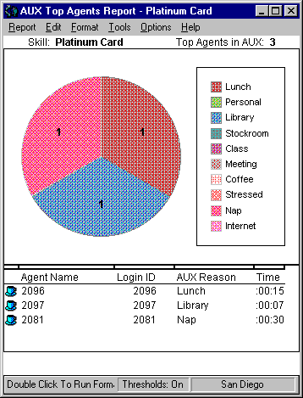

Split/Skill Graphical Call Profile Report
This report shows how well the split or skill you specify is performing compared to your call center’s predefined acceptable service level. You can access this report from the Real-Time Split/Skill Category selector menu.
The split/skill selected for the report and the predefined acceptable service level are displayed above the top graph. Legends appear to the right of each chart.
On the bottom graph, the horizontal axis represents the service interval in seconds, and the vertical axis represents the number of ACD calls answered/abandoned within the acceptable service level. The number displayed for each service interval is the upper limit of the interval. For example, if the first two intervals are "3" and "5," the first data point on the graph indicates the number of calls answered/ abandoned within 0-3 seconds, and the second data point indicates the number of calls answered/abandoned within 4-5 seconds.
This report has two charts:
- The top chart, a three-dimensional pie chart, shows the percentage of ACD calls answered within the predefined Acceptable Service Level and the percentage of ACD calls answered outside this level.
- The bottom chart, a stacked area graph, shows the number of ACD calls answered and abandoned within each service interval.

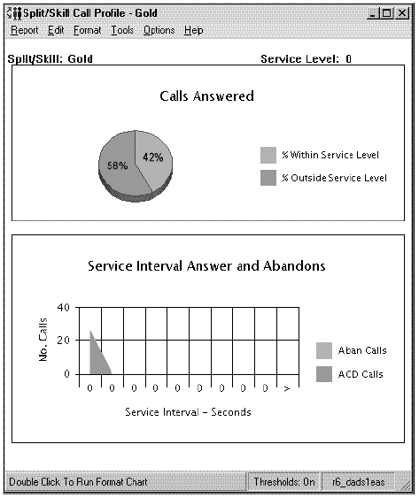

Split/Skill Graphical EWT Report
This report shows the current Expected Wait Time (EWT) for one or more of the splits or skills you specify. You can access this report from the Real-Time Split/Skill Category selector menu. The vertical axis of the chart is labeled with the names or numbers of the splits or skills selected for the report. A legend appears to the right of the chart.

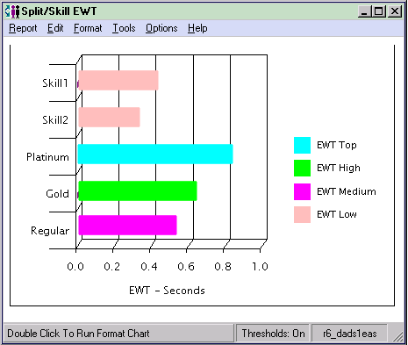

Split/Skill Graphical Queue Report
This report shows the number of calls waiting in queue, the amount of time that the oldest call has waited in queue, and trending for one or more splits/skills. You can use this report to view trends of calls waiting for several splits/skills. This report has four graphs. The two graphs on the left side of the report show the number of Calls Waiting (upper left quadrant) and the Oldest Call Waiting (lower left quadrant). The two graphs on the right side of the report show the trends for the last ten refresh intervals for the same data items. The legend shows which line corresponds to which split/skill. Each bar graph has a horizontal bar, on the left quadrant of the report, for each split/skill selected for the report. Each graph’s x-axis dynamically scales to the largest value of the items being reported. The x-axis of the Calls Waiting bar graph displays the number of calls (No. Calls) waiting in the split/skill queue. The x-axis of the Oldest Call Waiting bar graph displays the number of seconds the oldest call in the split/skill queue has waited.

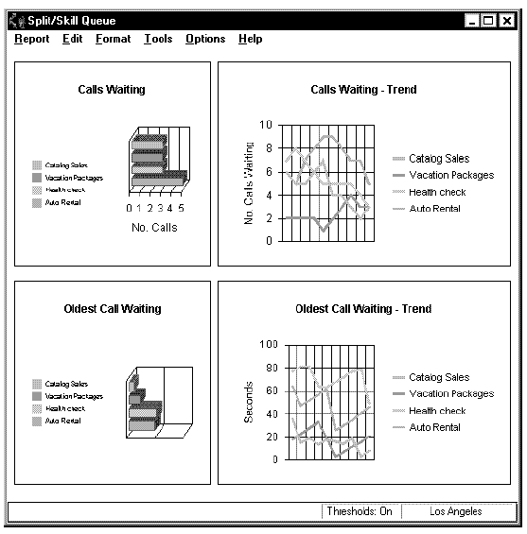

Split/Skill Graphical Skill Overload Report
This report is only available for customers who have DEFINITY ECS R6 or later switches with Expert Agent Selection (EAS) and have purchased Avaya™ Business Advocate. It shows the skill state (normal, unknown, overload1, overload 2) and trends for a selected skill. If Avaya™ Business Advocate is not activated, the fields of the report which pertain to Business Advocate will not be populated.
You can access this report from the Real-Time Split/Skill Category selector menu. The report caption displayed when the report is run reads “Skill Overload: xxx” where xxx is the skill name string specified by the Name Formats window of Tools/Options.
This report has two sections: a vertical bar chart and a rolling line chart.
- The vertical bar chart consists of:
- A vertical bar for each skill input for the report, showing the current skill state.
- The y-axis of the report will display, from the bottom up, “Normal,” “Overload1,” and “Overload2.”
- The title: Skill Overload Report
- By default, a legend displays. The legend will show the synonym for every skill specified in the input, or the skill number if no skill name has been defined.
- The rolling line chart consists of:
- When the report is started, only one data point (whether unknown, normal, overload1 or overload2) is displayed for each skill. With each refresh, the new status will be added to the previous refresh. This continues for 20 refreshes, at which time the oldest data will roll off the chart.
- The x-axis of the chart displays a tick mark for each report refresh.
- The y-axis of the chart displays, from the bottom up, “Normal,” “Overload1,” and “Overload2.”

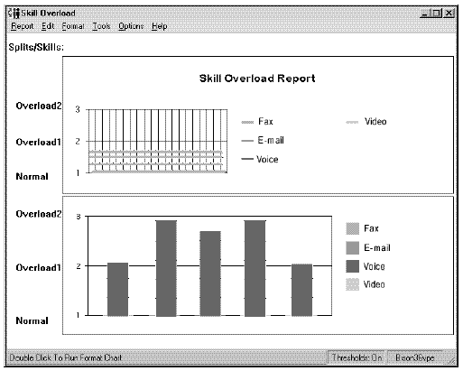

Split/Skill Graphical Staffing Profile Report
This report is available only for customers who have DEFINITY ECS R6 or later switches with EAS and have purchased Business Advocate. It shows how many of what type of agents are staffing a specified skill as Active, in Other, or in AUX. If Advocate is not activated, the fields of the report which pertain to Advocate will not be populated.
You can access this report from the Real-Time Split/Skill Category selector menu. Call center supervisors can use this report to see how many agents are active, in Other or in auxiliary work (AUX). This report will also show the supervisor what type of agents are in those fields.
This report has four charts. The charts contain the following information:
- The upper left quadrant chart shows Top agents staffed, active, in AUX, and in Other for the specified skill.
- The upper right quadrant chart shows Flex agents staffed, active, in AUX, and in Other for the specified skill.
- The lower right quadrant chart shows Reserve2 agents staffed, active, in AUX, and in Other for the specified skill.
- The lower left quadrant chart shows Reserve1 agents staffed, active, in AUX, and in Other for the specified skill.
You may change the report in Report Designer to display information on agents who are available (AVAIL).

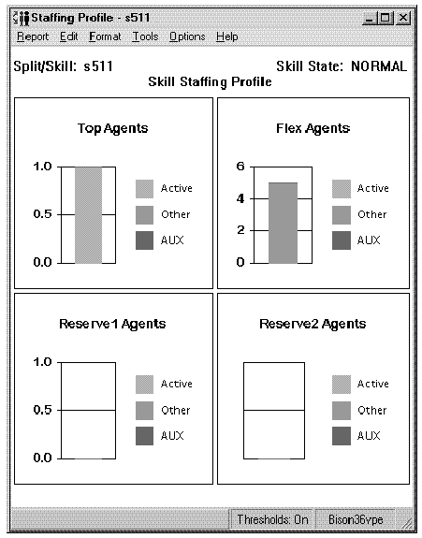

Split/Skill Graphical Status Report
This report shows the status of the agent, the amount of time in an agent state, and the split/skill statistics for individual agents. You can access this report from the Real-Time Split/Skill Category selector menu. From this report, you can drill down to the Real-Time or Integrated Agent Information, Work State, and Graphical AUX Agent (for DEFINITY ECS with EAS) reports. The chart type can be changed.
This report is available in both graphical and tabular formats. The table on the left side of the report lists the staffed (logged in) agents in the split/skill you specify, the state (workmode) each agent is currently in, the amount of time the agent has been in the current state, and the split/skill that the agent is in currently. If the Split/Skill column is empty, the agent is not currently on a call. The split/skill selected for the report is displayed above the table. By default, agent names are sorted alphabetically. If there are more staffed agents than can be displayed, a scroll bar appears on the right side of the table. To the left of each agent name (or login id, if names are not assigned) is an icon representing the agent’s state.
The three-dimensional pie chart in the upper-right quadrant shows the number of agents in each agent state (Avail, ACD, AUX, ACW, Ring, Other) for the selected split/skill. The number of agents in each agent state is displayed on the corresponding piece of pie. A legend is displayed to the right of the chart. The fields in the lower-right quadrant of the report display real-time split/skill information.

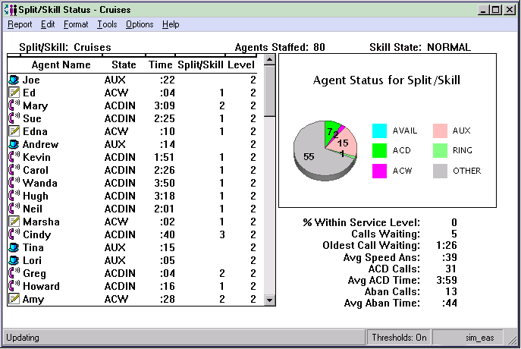

Split/Skill Graphical Top Skill Status Report
This report, available only with EAS, contains a table of top agents and their work state, a pie chart showing the composite top agent status, and a pie chart showing the composite reason codes for top agents who are in AUX. You can access this report from the Real-Time Split/Skill Category selector menu.
The table on the left bottom half of the report contains a row for each staffed agent for whom this skill is their top skill. The row shows an icon representing agent state, the agent names as defined in the Dictionary, the agent state for this skill, time in current state, and a reason code (as defined in the Dictionary) for the AUX work state. The Reason column is blank except for those agents who are in AUX work. This table also contains the skill in which the agent is active. This field is blank if the agent is in AVAIL, AUX, or OTHER work modes.
Call center supervisors can use this report for skill level distribution and to keep agents on ACD calls. In addition, this report shows what is happening with agents who are taking calls for this skill.
From this report, you can drill down to the Real-Time and Integrated Agent Information, Top Agents Work State, and Graphical Top AUX Agent reports. Even though a skill may be staffed by many agents, it is likely that only those for whom this is their top skill will be available to answer calls to this skill.
The two dimensional pie chart contains data only for the DEFINITY ECS with EAS. The two dimensional pie chart contains the following information:
- The composite status of top agents for the skill who are in AUX for each reason code.
- A legend displays the synonyms for reason codes that have been defined in the Dictionary. The legend is sorted in ascending order by reason code number, with the customer- defined synonym for reason code 0 at the bottom.
The three-dimensional pie chart contains the following information:
- The composite status of top agents for the skill in each of the work states.
- A legend in which a different color corresponds to each of the work states.
- Above the chart is the "Top Agents in AUX" heading.

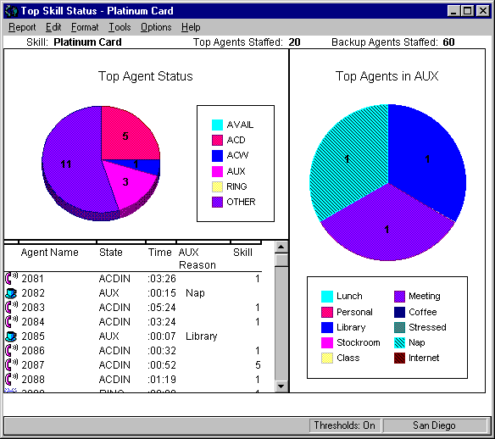

Reserve1 AUX Agents
This report, which is available only for customers who have DEFINITY ECS R6 or later switches with EAS and have purchased Avaya™ Business Advocate, displays the Reserve1 agents who are in AUX and the time in AUX, for a specified skill. When this report is accessed from the report menu, it displays as the Reserve1 AUX Agents Report. When it is accessed by drilling down from the AUX work state or Agent Location ID, it displays as the Reserve1 AUX Work State Report. When accessed as a drill-down report, this report will only contain Location ID if the report you drill-down from uses Location ID as an input.
You can access this report the following ways:
- From the Real-Time Split/Skill Category selector menu
- By drilling down to this report from the AUX work state of Reserve1 agents, or R1INAUX.
Call center managers can use this report to see the Reserve1 agents in each AUX work state, for a specified skill. For each agent, the manager will also be able to see information such as the length of time in the AUX work state.
This report consists of a table and two data fields. The report table contains a row for each agent who is in the specified state for the specified skill. The report caption will read “Reserve1 AUX Work State Report— xxx,” where xxx is the skill name string specified by the user.

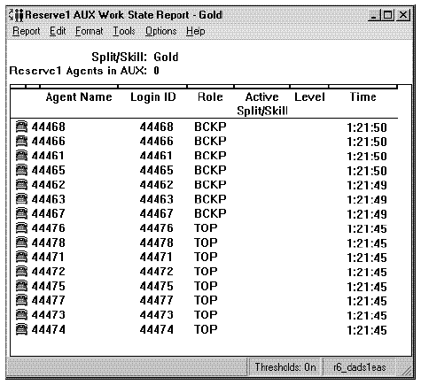

Reserve2 AUX Agents
This report, which is available only for customers who have DEFINITY ECS R6 or later switches with EAS and have purchased Avaya™ Business Advocate, displays the Reserve2 agents who are in AUX and the time in AUX, for a specified skill. When this report is accessed from the report menu, it displays as the Reserve2 AUX Agents Report. When it is accessed by drilling down from the AUX work state or Agent Location ID, it displays as the Reserve2 AUX Work State Report. When accessed as a drill-down report, this report will only contain Location ID if the report you drill-down from uses Location ID as an input.
You can access this report the following ways:
- From the Real-Time Split/Skill Category selector menu
- By drilling down to this report from the AUX work state of Reserve2 agents, or R2INAUX.
Call center managers can use this report to see the Reserve2 agents in each AUX work state, for a specified skill. For each agent, the manager will also be able to see information such as the length of time in the AUX work state. This report consists of a table and two data fields. The report table contains a row for each agent who is in the specified state for the specified skill. The report caption will read “Reserve2 AUX Work State Report— xxx,” where xxx is the skill name string specified by the user.

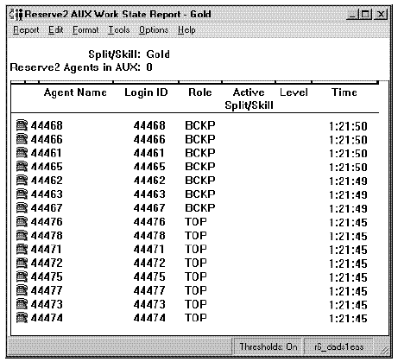

Skill AUX Report
This report shows, for one or more skills, the number of agents in AUX work with each reason code. You must have an ECS Release 5 switch or later with the EAS feature. You must be using reason codes. You can run the report without using the reason codes, but all agents will be in reason code zero when in AUX.

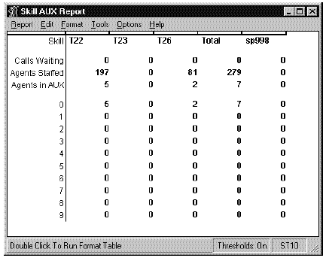

Split Status
This report shows how long the oldest call in queue has been waiting, how many calls are currently waiting to be answered, the agent names, the agent states, the length of time an agent has been in the state, and the split associated with the call the agent is currently handling.
Note: The Split Status report is available on switches that do not have the EAS feature. If you have the EAS Feature, this report is replaced with the Skill Status Report described below.
All agents logged into the selected split are displayed. You can scroll to view agents that you cannot see on the report. If an agent is on an ACD call or in the ACW state, a single split is displayed that corresponds to the ACD call or ACW. If the agent is available, all of the splits are displayed. If the agent is in AUX in all splits, all splits are displayed. For a Generic 3 Version 2 or later version switch without the Expert Agent Selection (EAS) feather, an agent can be logged into a total of four splits.
The EWT value is updated whenever a call queues to the split. If no call has queued for 2 minutes, CMS will request the switch to send the current EWT values for the split.

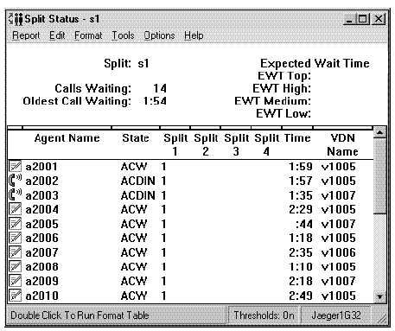

Skill Status
This report shows how long the oldest call has been waiting in queue, how many calls are currently waiting to be answered, the agent names, the agent states, the agent’s skill level, and the number of the skill for which the agent is handling the call or is in after call work.
This new report also provides:
- Provides agent AUX reason codes.
- Provides the agent login identification and the agent name.
- Provides the level for the agent’s currently active skill (ACD call or ACW session). This level can be any level from 1 to 16, or R1 or R2.

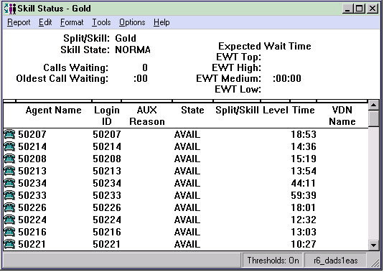

Skill Top Agent
This report is similar to the Split/Skill Report, but shows counts of agents for whom the skill is the top skill. It also shows a count of agents for whom the skill is a backup skill.

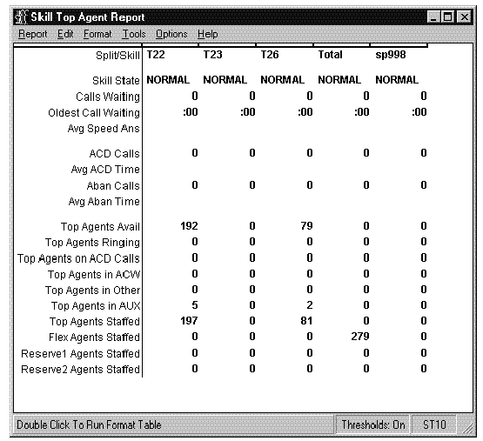

Split/Skill Report
The Split/Skill report simultaneously displays real-time call-handling information on a number of splits or skills. It allows the supervisor to evaluate and compare the workload and call-handling performance between splits/skills, and to determine agent reassignment. Additionally, the supervisor can evaluate other ACD configuration alternatives which can be used to balance workloads and reduce abandoned calls.
You can enter a range or a list of splits/skills which the report will cover. If you only want to view one split or skill, you may size the window smaller. In this report, the OTHER state displays for agents who are on calls or in after call work state for other splits or skills. For agents in split/skills with the many forced option of Multiple Call Handling for Generic 3 Version 4 and later switches, a queued call is not delivered to an agent position if there is no available call appearance. If the agent has no available call appearance, then the agent is either on a call or has all calls on hold. In either case, the agent is not available.

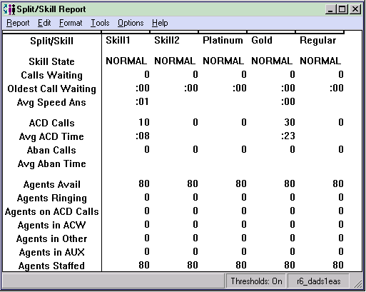

Split/Skill by Location
The Split/Skill by Location report supports the Agent Site Tracking feature introduced with R3V8 CMS and R8 Supervisor. This report tracks agents by their split/skill location ID. The Split/Skill by Location report displays real-time agent call-handling information on a single split or skill. It allows the supervisor to evaluate the workload and call-handling performance on the split/skill, and to determine agent reassignment.

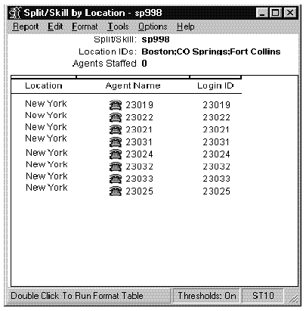

Top Agent Status
This report is the same as the Skill Status Report, except that it only shows status for agents for whom the selected skill is the top skill. "Top Agents" are agents for whom the skill is their highest-level skill. If agents have more than one skill at the highest level, then the first one administered is the top skill. The EWT value is updated whenever a call queues to the skill. If no call has queued for 2 minutes, CMS will request the switch to send the current EWT values for the skill. You must have a Generic 3 switch with the EAS feature.

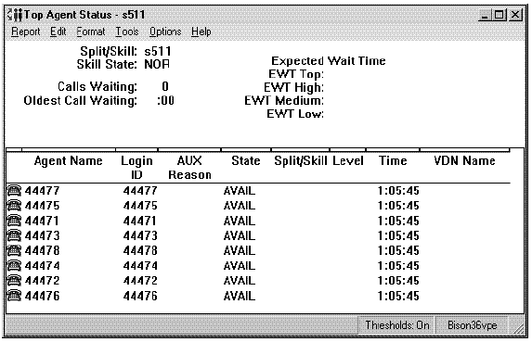

Real Time Trunk/Trunk Group Reports

Trunk Group Report
The Trunk Group report displays the current status of each trunk in a selected trunk group. This information is useful in identifying overused or underused facilities and in general troubleshooting.

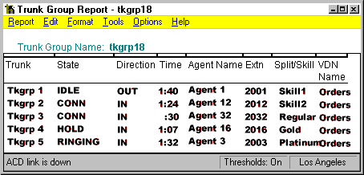

Real Time VDN Reports

VDN Call Profile
This report displays the numbers of answered/connected and abandoned calls to the specified VDN within the administered service level increments. It also displays the percentage of calls answered or connected within the acceptable service level. Calls are displayed in ten separate columns, with each column representing a progressively longer wait time for the call. For example, the first field shows calls that were answered in less than or equal to PERIOD1 seconds, the second field shows calls that were answered in less than or equal to PERIOD2 seconds, but greater than PERIOD1 seconds, and so on.

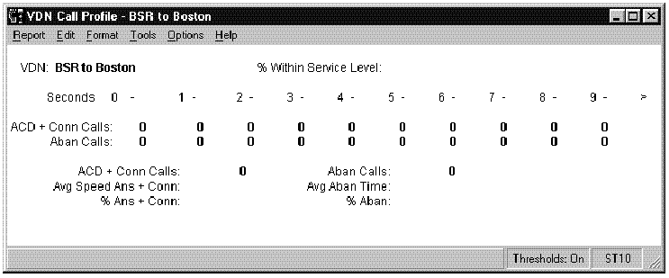

VDN Graphical Call Profile
This report shows how calls to the VDN you specify are being handled compared to your call center’s predefined acceptable service level. Call center supervisors can use this report to look at VDN calls answered within the acceptable service level and service interval answer and abandons. This report contains two charts, a three-dimensional pie chart and a stacked area graph. The three-dimensional pie chart contains the percentage of ACD calls answered within the predefined acceptable service level and the percentage of ACD calls answered outside this level. The VDN selected for the report and the predefined acceptable service level are displayed above this chart. The stacked area graph contains the following information:
- The number of ACD calls answered and abandoned within each service interval.
- The x-axis represents each of the defined service intervals in seconds, and the y-axis represents the number of ACD calls answered/abandoned within each of the defined service levels.
- The number displayed for each service interval is the upper limit of the interval. For example, if the first two intervals are "5" and "10," the first data point on the graph shows the number of calls answered/abandoned within 0-5 seconds, and the second data point shows the number of calls answered/abandoned within 6-10 seconds.

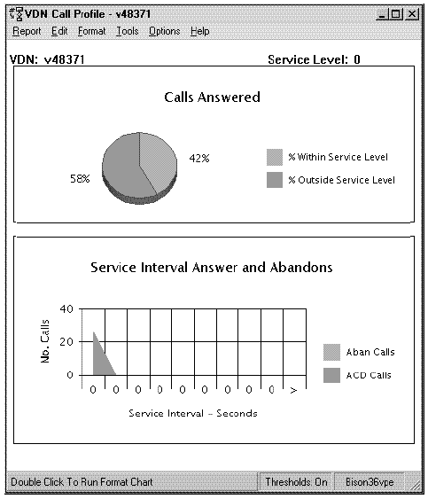

VDN Skill Preference
This report displays information about call handling for the VDN as a whole and lists the number of calls handled by each of the VDN skill preferences. This report displays data on the handling of calls to the VDNs by VDN skill preference. If a specific skill in the vector is also administered as a VDN skill preference for the associated VDN, data for that skill preference shows in this report.

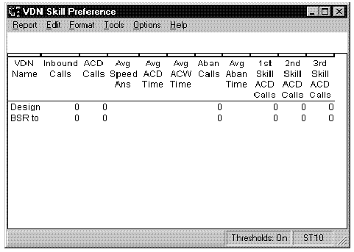

VDN Report
This report displays information about how calls to the specified VDNs are being handled during the current interval.

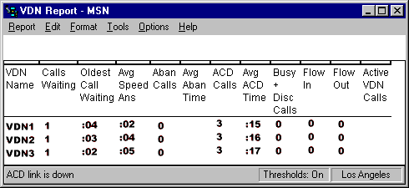

Real Time Vector Reports

Vector Report
The Vector report displays the information about how calls to the specified vectors are being handled during the current interval.

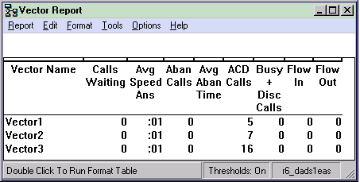

Real Time Drill Down Reports
Supervisor reports allow you to "drill-down" to very detailed information from a variety of places. A "drill-down" report is a report that gives you very specific information on an agent or a work state in a split/skill.

Top Agent Work State
This report shows top agents who are in the specified work state and the time in the state. In addition, this report shows all of the agents that are staffed even if they are not in a particular state for the specified split/skill. This report contains:
- A table with a row for each top agent currently in the selected work state.
- Top agent name, login ID, time in state, split/skill, and the skill level and role in the skill in which the agent is active in each row of the table.
- The user will be able to specify sort by agent name, login ID, time in state, split/skill, skill level and role.
- The user will be able to specify a primary and a secondary sort key.
By default, the table will be sorted by split/skill for the primary sort, then by time in state (in descending order) for the secondary sort. From this report, you can drill down to Real-Time or Integrated Agent Information reports. Call Center Supervisors can use this report to look at all the top agents in a particular work state, and to see how long an agent has been in this work state, the skill for which they are occupied, the skill level assigned to the agent for this skill, and the role the agent has in this skill.

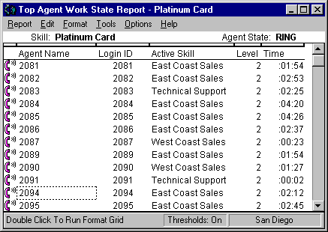

Work State
This report shows all of the agents who are in the specified work state and the time in state. This report is available on all switches. This report contains:
- A table with a row for each top agent currently in the selected work state.
- Agent name, login ID, time in state, split/skill, and the skill level and role for the skill in which the agent is active in each row of the table.
- The user will be able to specify sort by agent name, login ID, time in state, split/skill, and skill level.
- The user will be able to specify a primary and a secondary sort key. By default, the table will be sorted by split/skill for the primary sort, then by time in state (in descending order) for the secondary sort.
When you drill down to this report from another report, this report shows all of the agents in that work state for that split or skill only. Call Center Supervisors can use this report to look at all agents in a particular work state, and to see how long an agent has been in this work state, the split/skill for which they are occupied, the skill level assigned to the agent for this skill, and the role the agent has in this skill.

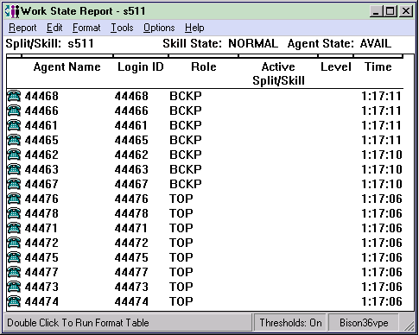

Historical Reports
Historical reports display, report, and summarize the past performance of any measured subset of the ACD. Historical reports display past data for various agent, split/skill, trunk/trunk groups, VDN, and vector activities, such as number of ACD calls, abandoned calls, average talk time, and average speed of answer. The information in historical reports will give you a sound basis for decisions concerning the following:
- Mix of trunk facilities
- Split or skill size
- Agent assignments
- Consistent and objective performance standards
- Performance evaluations.
When you generate a historical report, the totals for the report columns are on the top line of the report under the headings. There are four types of historical reports:
- Interval reports – Contain breakdowns of data by the defined interval (15, 30, or 60 minutes).
- Daily reports – Display summarized interval data, one line for each day.
- Weekly reports – Display summarized daily data for the week(s) specified, one line for each week.
- Monthly reports – Display summarized daily data for the month(s) specified, one line for each month.
All four types are not available for each report. The Select-a-Report window lists reports based on which types are available.
The following diagram shows how the Historical reporting system is structured. The sample reports provided immediately following the diagram are organized in the same order as outlined in the diagram. Please note that representative reports have been included to demonstrate the power and flexibility of the available reports; an example of each report available from CMS Supervisor is provided with the documentation included with the system.

Historical Reporting System Structure

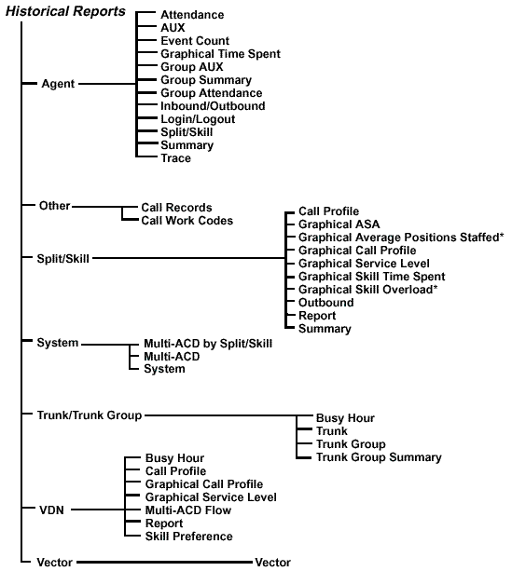

Historical Agent Reports

Agent Attendance Report
The Agent Attendance report gives the total staffed time, ACD time, ACW time, AUX time, time in the ringing state, extension time, available time, and the number of calls handled by an agent for the specified time period for all splits or skills the agent was logged into. The Agent Attendance report is available in daily, weekly, and monthly versions.

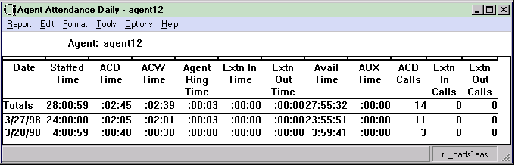

Agent AUX Report
The Agent AUX (Auxiliary Work) report is based on the Agent Summary and Agent Attendance reports. This report shows the total staffed time, total AUX time, and AUX time for each reason code for an agent. The Agent AUX report is available in interval, daily, weekly, and monthly versions.

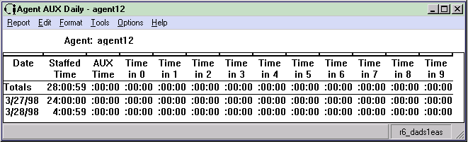

Agent Event Count Report
The Agent Event Count report shows the total number of times that an individual agent pressed an Event Count (sometimes referred to as Stroke Count) key for all splits/skills. An Event Count key can represent any call event, including a successful sale, a call from a demographic category, or a response to a promotion. Avaya CMS records an event occurrence each time that an agent presses an Event Count key on his or her voice terminal while the agent is on an ACD call or in call-related ACW. The Event Count report is available in interval, daily, weekly, and monthly versions.

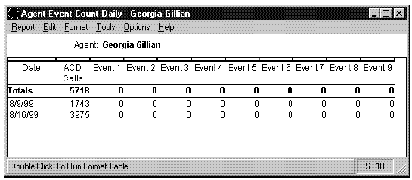

Agent Graphical Time Spent
This report shows historical information and statistics for the specified agent. This report is available in daily version only. Call center supervisors can use this report to get an idea of how much time an agent spent on ACD calls, in available state, in ACW, in AUX, and so on, for a particular day. This report enables the supervisor to tell how much time the agent spent in AUX work state for each of the reason codes defined for this Call Center.

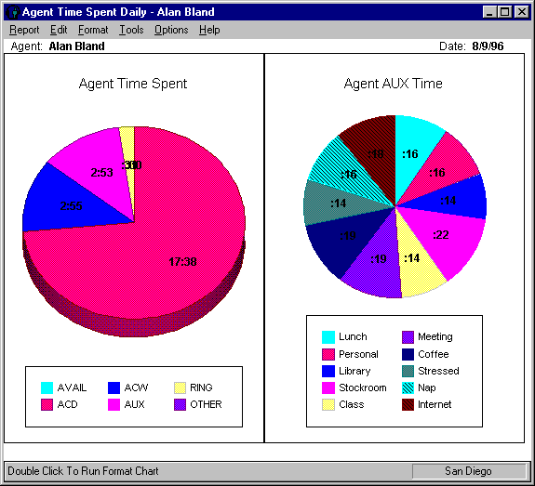

Agent Group Attendance
The Agent Group Attendance report summarizes staffed time, ACD time, ACW time, AUX time, time in the ringing state, extension time, available time, and number of calls handled for each agent in an agent group for the specified time period. The Agent Group Attendance report is available in daily, weekly, and monthly versions. The Totals column in the report(s) displays the totals for all agents in the group you have selected. Individual agent entries in this report show the totals for a particular agent.

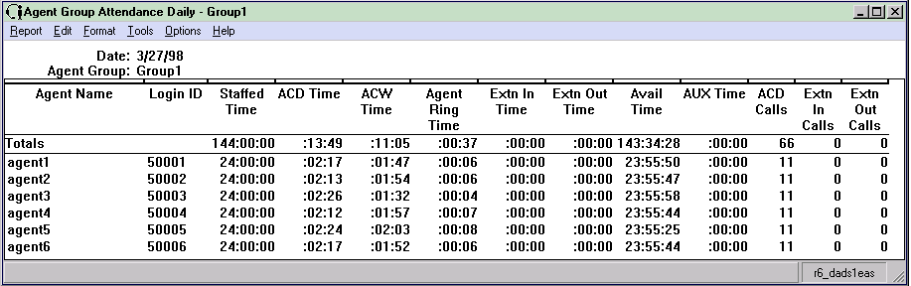

Agent Group Summary
The Agent Group Summary report summarizes the daily activities of every agent within a specific group. Agents in a group may share common characteristics, such as being newly hired or top performers, or they may simply be part of a more manageable subdivision of a skill. You can use this report to compare individuals within a group. This report lists the totals for each agent in the group summed over all splits/skills that the agent was logged into during the time period covered in the report. This report also contains information on the overall occupancy of the selected agent group, expressed as a percentage, both with and without ACW included. The Agent Group Summary report is available in daily, weekly, and monthly versions.

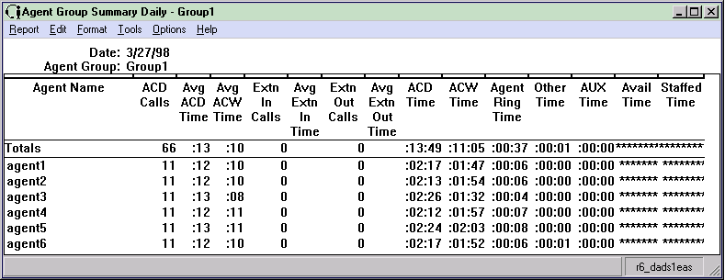

Agent Group AUX
The Agent Group AUX report shows the total staffed time, total AUX time, and AUX time for each reason code for all agents in an agent group. The Agent Group AUX report is available in daily, weekly, and monthly versions.

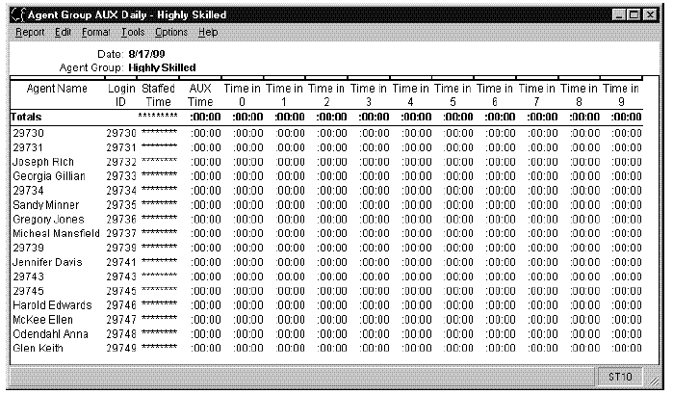

Agent Inbound/Outbound Call
The Agent Inbound/Outbound Call report is a detailed breakdown of the inbound and outbound calls handled by an agent. The report sums the total over all the splits or skills the agent was logged into for the specific period covered. This report is available in interval, daily, weekly, and monthly versions.

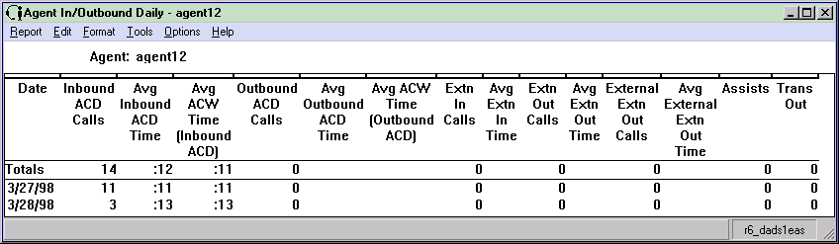

Agent Login/Logout (Skill)
The Agent Login/Logout (Skill) report shows the times that agents in a given skill logged in and logged out, the reason codes associated with the logout (if there is one), and the skills with which the agents logged in and out. The Login/Logout (Skill) report is available in daily version only.

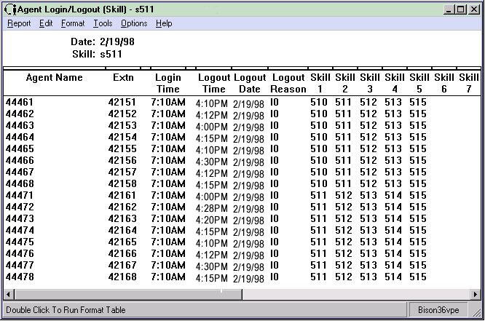

Agent Split/Skill Report
The Agent Split/Skill report shows an individual agent’s performance by split or skill. The Agent Split/Skill report is available in interval, daily, weekly, and monthly versions. Each row in the report shows the total for the specified time for a particular split/skill the agent was logged into. However, the Totals: row shows the totals over the day for all splits or skills for this agent. Talk times are shown as totals, not as averages.

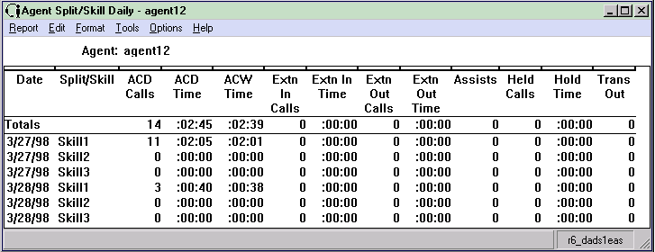

Agent Summary
The Agent Summary report shows the activities and performance of an individual agent for all splits or skills of which the agent is a member. It represents the totals over the specified time period for all splits or skills the agent was logged into. This report also includes information on agent occupancy, expressed as a percentage of total work time, both with and without ACW. The Agent Summary report is available in interval, daily, weekly, and monthly versions.

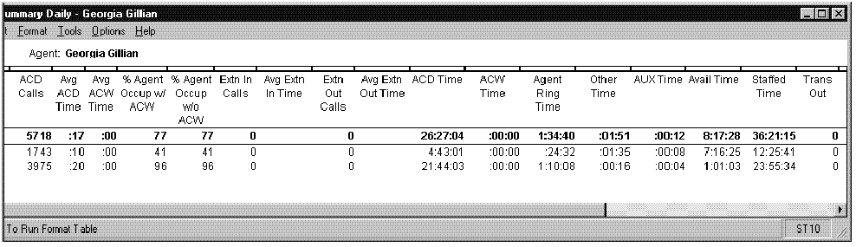

Agent Trace by Location
The Agent Trace by Location report lists each agent activity and the time it occurred, by agent location ID. This information could be useful when evaluating how well agents are using their time.

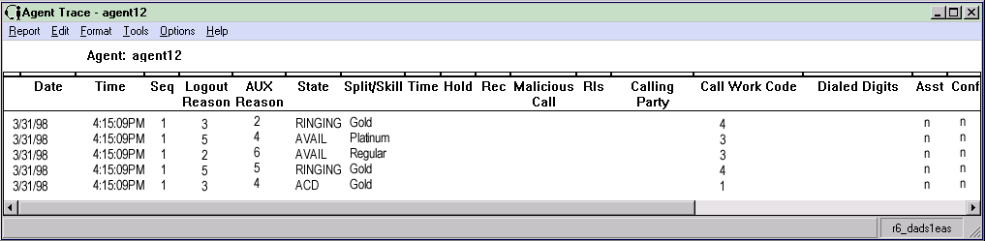

Historical Other Reports

Call Records Report
The Call Records report allows you to view selected information about each call. For example, you might have a caller that complained about being put on hold three times and then transferred. This report gives you this type of information about a call.
Call Records allow you to view information about particular calls. Each call is represented by one or more records, because a new record is created whenever the call is conferenced or transferred. However, all records for a particular call will have the same call ID, so that you know the records represent the same call. With call records, the call is tracked up until it is transferred or conferenced. At the point of a conference or transfer, a new call record is generated for the call. The standard Call Records report is provided as a model for customized call record reports. Most call record reporting will need to be done from Designer reports tailored to your needs.

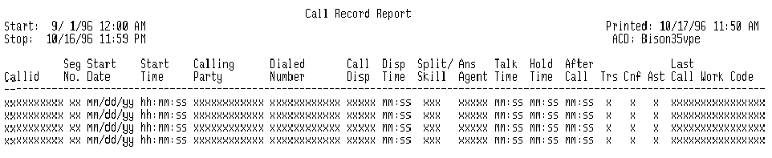

Call Work Code Report
Use the Call Work Code report to track certain call activities of your call center, such as special sale items, complaints, or how many times a customer made a purchase based on a special sales campaign. Agents enter a specific call work code that is associated with a particular call activity when the activity occurs. Those entries are tracked on this report. To produce data in this report, you must have the Call Work Codes feature active on DEFINITY ECS.
The Call Work Code report is available in daily, weekly, and monthly versions. The range of call work codes that may be reported on cannot exceed 1000. Call Work Codes can only be nine or fewer digits in each code if you want to assign names to the codes in the Dictionary.

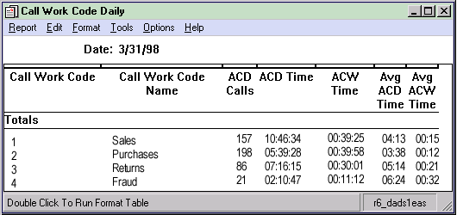

Historical Split/Skill Reports
CMS Supervisor Split/Skill reports give you access to information on your splits or skills. This information includes looking at the percentage of calls answered within set service levels by split/skill, how many calls were handled by each agent in a split/skill, and summarizing the activity for an entire split/skill.

Split/Skill Call Profile
The Split/Skill Call Profile report shows the number of calls answered and abandoned in time increments that you administer. This report also displays your acceptable service level. Since this report shows you how long it takes for calls to be answered or abandoned, you can determine how long a caller is willing to wait for an agent before hanging up. With this information, you can determine the appropriate answering speed required to reduce abandoned calls.
Calls are displayed in ten columns, with each column representing a progressively longer wait time. The Split/Skill Call Profile report is available in daily, weekly, and monthly versions.

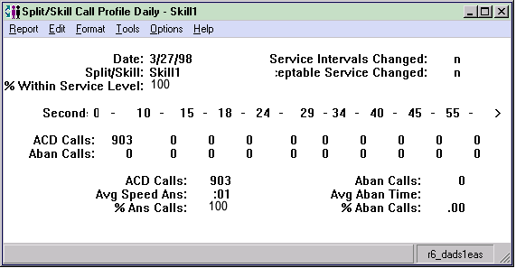

Split/Skill Graphical Average Speed of Answer
The Split/Skill Graphical ASA (Average Speed of Answer) report shows the average speed of answer for ACD calls answered in each selected split/skill for each selected interval.
The Split/Skill Graphical ASA (Average Speed of Answer) Daily report shows the average speed of answer for ACD calls answered in selected splits/skills for selected days.
The bottom right of the report contains a status bar that displays the name of the ACD chosen through the Report Selector dialog box. A legend on the right side of the report shows the names of the selected splits/skills.

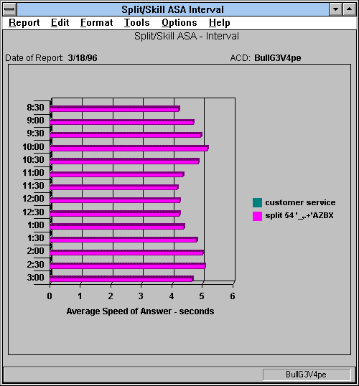

Split/Skill Graphical Average Positions Staffed
This report is available for customers who have purchased Avaya™ Business Advocate and the DEFINITY ECS R6 or later. This report shows, for a specified skill, the maximum agent positions allocated for the skill, as well as the average positions staffed. This allows call center supervisors to see historically how many agents were counted on for a skill in comparison to how many agents were actually available on the skill.
This report is available only on the DEFINITY‚ ECS R6 or later with EAS. If Avaya™ Business Advocate is not activated, then the fields on the report that pertain to Business Advocate will not populate. The primary component of this report is a 2-D vertical bar chart. The chart contains the following components:
- The y-axis of the chart has gradients for the number of agents.
- The x-axis of the chart displays the specified time intervals.
- The legend displays “Max Post Allocated” and “Avg Pos Staffed.”

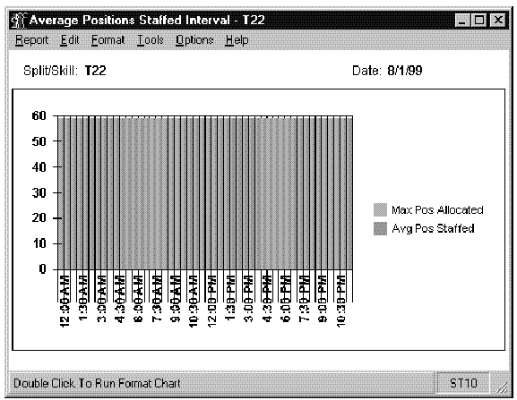

Split/Skill Graphical Call Profile
This report shows how well the split or skill you specify performed compared to your call center’s predefined service levels for the date you specify. This report has four charts and displays a collection of split/skill call profile related data items at the top of the report. A legend appears to the right of each chart.
The three-dimensional pie chart in the upper-left quadrant shows the percentage of ACD calls answered within the Acceptable Service Level and the percentage of ACD calls answered outside this level. The numerical value represented by each pie piece is shown inside the pie chart, and the boxes to the right of each graph are a legend.
The three-dimensional pie charts on the right side of the report show the Percentage Answered Distribution (upper right quadrant) and the Percentage Abandoned Distribution (lower right quadrant) for each service level increment. The numerical value represented by each pie piece is shown inside the pie chart.
The horizontal bar chart in the lower-left quadrant shows the actual number of ACD calls answered within each service interval. The horizontal axis represents the number of calls answered or abandoned. The vertical axis represents the customer’s service intervals. For each of these intervals, two horizontal bars are displayed. One bar shows the number of answered ACD calls, and the other bar shows the number of abandoned calls. The number displayed for each service interval is the upper limit of the interval. For example, if the first two intervals are 5 and 10, the first data point on the graph indicates the number of calls answered/abandoned within 0-5 seconds, the second data point indicates the number of calls answered/abandoned within 6-10 seconds.

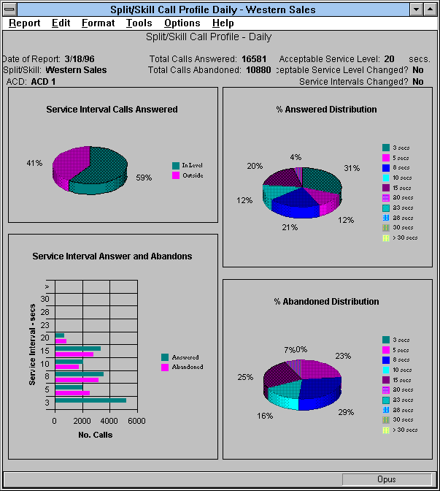

Split/Skill Graphical Multi-ACD Service Level
The Split/Skill Graphical Multi-ACD Service Level Report shows the Percent in Service Level achieved for a skill selected from one or more ACDs for each day. You can compare a split/skill in different ACDs and use the information to:
- Determine workload
- Review Percent in Service Level for each ACD
- Evaluate call-handling performance
- Reassign agents
- Perform other ACD configuration alternatives for balancing workloads and/or reducing abandoned calls.
You can specify a single split/skill across ACDs. The Split/Skill Graphical Multi-ACD Service Level report is only available in a daily version. The Split/Skill Graphical Multi-ACD Service Level report can include information on up to eight ACDs. This report is only available for DEFINITY R8 ACDs.

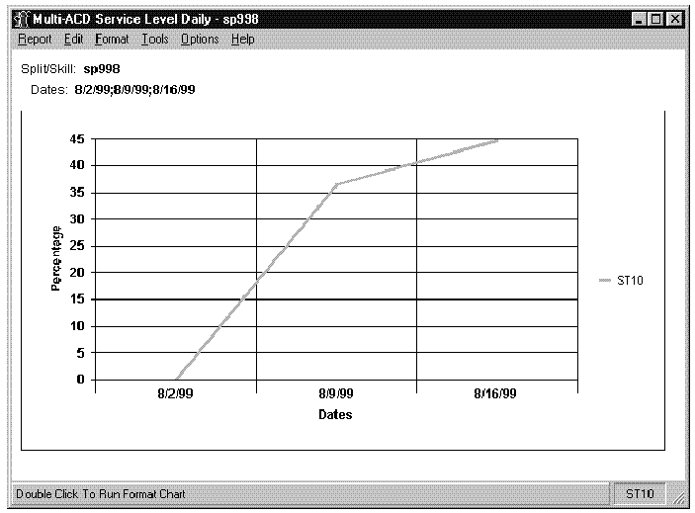

Split/Skill Graphical Service Level
This report shows the percentage of ACD calls answered within the predefined acceptable service level and the percentage of ACD calls abandoned for the date and split or skill you specify. Each set of vertical bars is labeled with the start time for the service interval. The box below the chart is a legend.

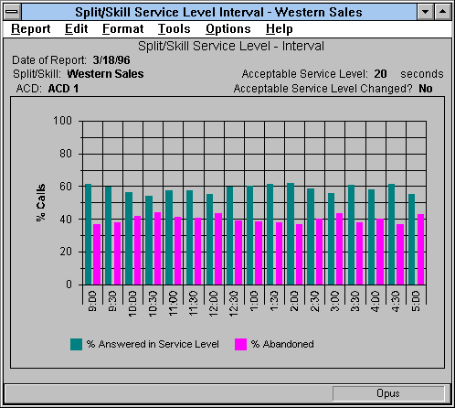

Graphical Skill Time Spent
This report shows how much time the agents staffed in the specified split or skill spent in each work state. It also shows the composite time spent in the AUX work state for each of the reason codes defined for this Call Center. Call center supervisors can use this report to estimate how much time agents in this split/skill spent on ACD calls, in available state, in ACW, in AUX, etc. for a particular day. This report enables supervisors to tell how much time the agents in this split/skill spent in AUX work state for each of the reason codes defined for this call center.
This report can display a three-dimensional pie chart that shows the amount of time (in hours and minutes) that the agent spent in each work state. By default, the percentage is shown inside of each section of the pie chart. A legend displays a different color for each of the agent work states (dictionary-defined synonym for each work state).
This report displays a three-dimensional pie chart that shows the reason codes for the time that the agents spent in AUX work mode. The percentage of AUX time (in hours and minutes) agents spent in AUX for each reason code is displayed inside the slice of the pie chart. A legend to the right of the pie chart shows a different color for each of the reason codes. This legend contains the dictionary-defined reason codes or numbers (if the reason codes have not been defined in Dictionary).

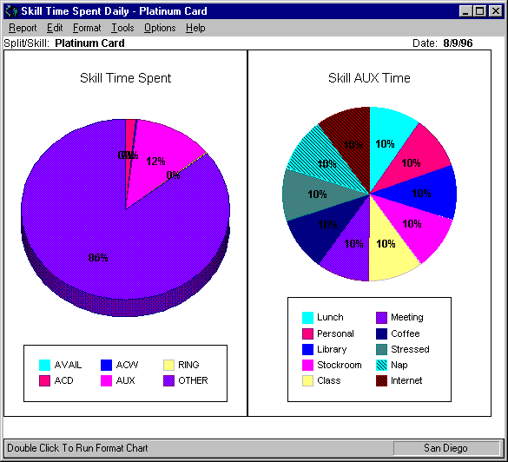

Graphical Skill Overload
The Graphical Skill Overload report shows how much time each skill has spent in normal versus overload condition for the intervals specified for a particular day. If Avaya™ Business Advocate is not activated, the fields of the report which pertain to Business Advocate will not be populated. This report displays a horizontal bar chart with a horizontal bar for each skill. If you notice a trend toward increased time in overload state, you may need to train or hire additional agents for that skill.

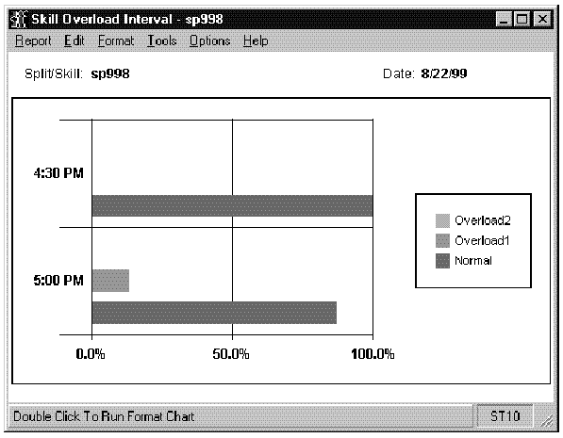

Split/Skill Outbound
The Split/Skill Outbound report displays the numbers and average talk times for each type of outbound call for a given split/skill. It is useful primarily for splits/skills that use an adjunct to deliver outbound ACD calls or to dial outbound extension calls. This report requires the Outgoing Call Management application of ASAI. The Split/Skill Outbound report is available in interval, daily, weekly, and monthly versions.

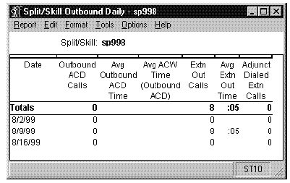

Split/Skill Report
The Split/Skill Report shows the calls handled, agent time and assists, and transfers and holds for each agent in a split/skill. This report shows only the time each agent worked in this particular split/skill. An agent could have worked in other splits/skills during the day. The Split/Skill Report is available in daily, weekly, and monthly versions.

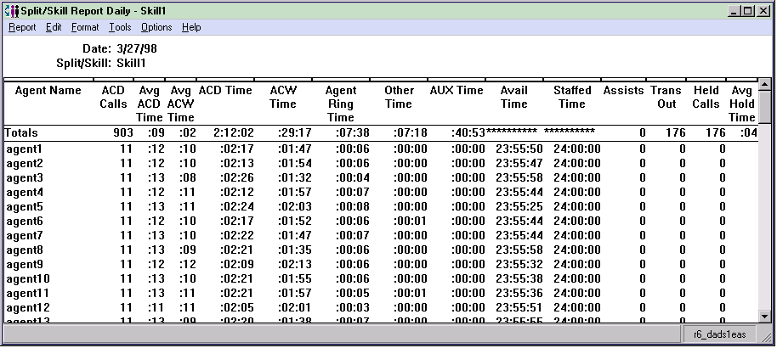

Split/Skill by Location
The Split/Skill by Location Report shows the calls handled, agent time, location ID for the agent terminal, and work, AUX, and other time for each agent in a split/skill. This report shows only the time each agent worked in this particular split/skill. An agent could have worked in other splits/skills during the day. This report supports the Agent Site Tracking feature, which must be enabled to see meaningful data on the report. The Split/Skill by Location Report is available in a daily version only.

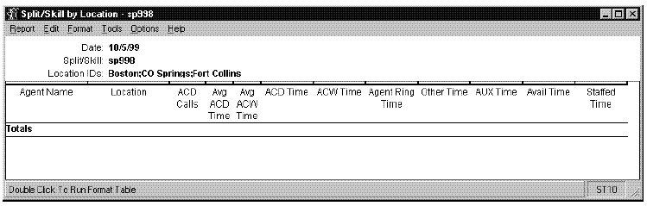

Split/Skill Summary
The Split/Skill Summary report summarizes the activity for an entire split or skill by time. You could use this report to analyze the overall performance of a split/skill or to compare two or more comparable splits/skills. Direct agent call data are not included in any of the Split/Skill Summary reports. Direct agent calls are considered calls to the agent instead of calls to the split/skill. If you wish to include direct agent calls as split/skill calls, you can create a Designer report using the agent table data. The Split/Skill Summary report is available in interval, daily, weekly, and monthly versions.

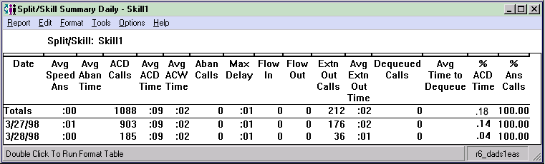

Historical System Reports
CMS Supervisor system reports allow you to access summary data on a set of measured splits/skills for a particular ACD, the summary data over all splits/skills for a particular ACD, and the call data on similar splits/skills for different ACDs.

Graphical Maximum Delay
The System Graphical Maximum Delay report shows the maximum delay for one split/skill in one or more ACDs for each day selected. You can compare the split/skill across ACDs and use the information to determine which ACD has the longest delay in answering calls. You can specify one split/skill available across ACDs. The System Graphical Maximum Delay report is available in a daily version. Standard multi-ACD reports can include information on up to eight ACDs. This report is only available for DEFINITY R8 ACDs.

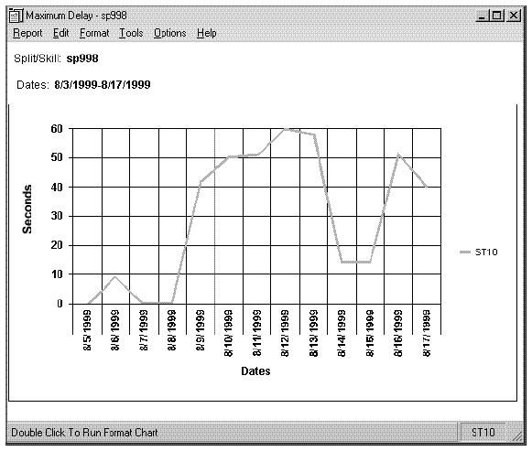

Multi-ACD by Split/skill
The System Multi-ACD by Split/Skill report displays call-handling information on different splits/skills for different ACDs. You can compare similar splits/skills in different ACDs and use the information to:
- Determine workload
- Evaluate call-handling performance
- Reassign agents
- Perform other ACD configuration alternatives for balancing workloads and/or reducing abandoned calls.
You can specify a list of splits/skills available for each ACD desired. The System Multi-ACD Report by Split/Skill report is available in daily, weekly, and monthly versions. Standard Multi-ACD reports can include information on up to eight ACDs.

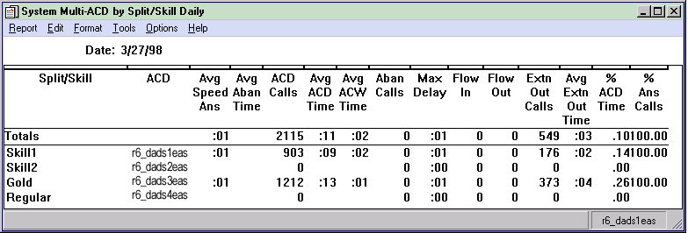

Multi-ACD
The System Multi-ACD report summarizes data over all splits/skills in the ACD for each ACD requested. This allows you to evaluate and compare different ACD configurations to determine workload and call-handling performance. After reviewing this report, you could choose different ACD configurations to balance workloads and/or reduce abandoned calls. If you have vectoring, you may want to create a Designer report that summarizes data over all VDNs instead of over all splits/skills. The System Multi-ACD report is available in daily, weekly, and monthly versions. Standard Multi-ACD reports can include information on up to eight ACDs.

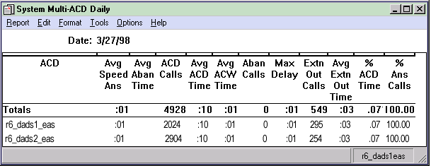

System
The System report summarizes the activity for a set of splits/skills for the same ACD. You can use this report to compare split/skill performance for splits/skills performing similar functions for the same ACD. The System report is available in daily, weekly, and monthly versions.

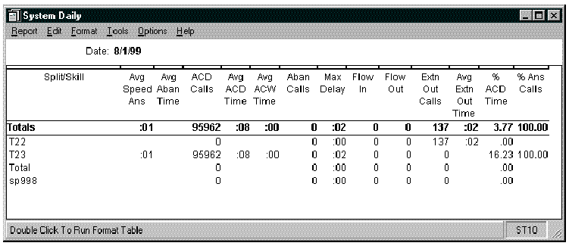

Historical Trunk/Trunk Group Reports
Trunk and Trunk Group reports display traffic data for a single trunk, summarize the incoming and outgoing traffic of every trunk in a trunk group for a specific time period, display the level of incoming and outgoing call traffic for an individual trunk group, or display the busiest hour of the day for each trunk group you select.

Trunk/Trunk Group Busy Hour
The Trunk/Trunk Group Busy Hour report displays the busiest hour of the day for each trunk group you select. The busiest hour is calculated as a set of contiguous intervals that make up an hour (one 60-minute interval, two 30-minute intervals, or four 15-minute intervals) in which the total holding time for the trunks in the trunk group was the maximum for the day. The Trunk/Trunk Group Busy Hour is available in daily version only. The busiest hour is calculated as a set of contiguous intervals that make up an hour (one 60-minute interval, two 30-minute intervals, or four 15-minute intervals) in which the total holding time for the trunks in the trunk group was the maximum for the day. You cannot customize this report.

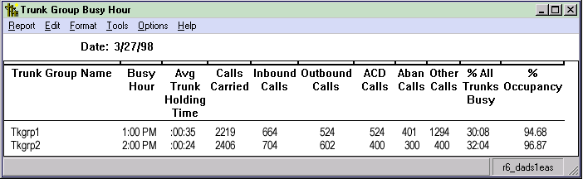

Trunk
The Trunk report displays call traffic data for a single trunk. With this report, you can review trunks in any measured trunk group. You can use this report to verify that call traffic levels for a trunk are appropriate throughout the time period specified. You can also monitor outgoing calls made throughout the day. The Trunk report is available in interval, daily, weekly, and monthly versions. The report item Centum Call Seconds (CCS) is the number of 100-second increments in which the trunk was busy during the intrahour interval. A trunk is "seized’’ while the call is both in queue and connected to an agent. Therefore, wait time for abandoned calls is figured into the CCS figures. For example, since a half-hour has 1800 seconds, the maximum CCS for each trunk in a trunk group is 18 CCS. Multiplying 18 CCS by the number of trunks in a trunk group gives you the maximum occupancy for the trunk group, which you can then compare with your actual CCS. If your intrahour interval is 15- or 60-minutes, your number will be different.

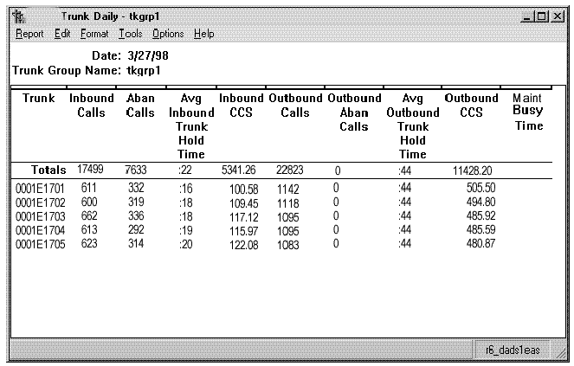

Trunk Group
The Trunk Group report summarizes the incoming and outgoing traffic of every trunk in a trunk group for the specified time period. You could use this report to verify that the number of trunks available to your splits/skills is appropriate and to monitor the number of outgoing calls. Also, because it lists trunks by physical location on the switch and totals trunk failures, the Trunk Group report can be useful for troubleshooting problems with trunks.
The Trunk Group report is available in daily, weekly, and monthly versions. The report item Centum Call Seconds (CCS) is the number of 100-second increments in which the trunk was busy during the intrahour interval. A trunk is "seized’’ while the call is both in queue and connected to an agent. Therefore, wait time for abandoned calls is figured into the CCS figures. For example, since a half-hour has 1800 seconds, the maximum CCS for each trunk in a trunk group is 18 CCS. Multiplying 18 CCS by the number of trunks in a trunk group gives you the maximum occupancy for the trunk group, which you can then compare with your actual CCS. If your intrahour interval is 15 or 60 minutes, your number will be different.
For the DEFINITY ECS and Generic 3 switches, trunks that fail are immediately put in the Maintenance Busy State.

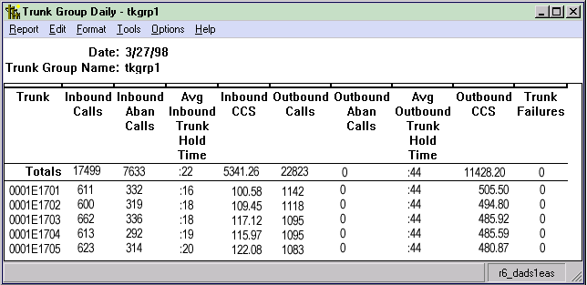

Trunk Group Summary
The Trunk Group Summary report shows the level of incoming and outgoing call traffic for an individual trunk group. You could use this report to verify that the number of trunks available to your splits is appropriate and to monitor the number of outgoing calls. The Trunk Group Summary report is available in interval, daily, weekly, and monthly versions. For both inbound and outbound calls, Call Carried = Calls Answered + Calls Abandoned + Other Calls. Also, Other Calls = Calls Given a Busy Signal + Calls Disconnected by the Switch + Calls Answered by an Unmeasured Agent. The report item Centum Call Seconds (CCS) is the number of 100-second increments in which the trunk was busy during the intrahour interval. A trunk is "seized’’ while the call is both in queue and connected to an agent. Therefore, wait time for abandoned calls is figured into the CCS figures. For example, since a half-hour has 1800 seconds, the maximum CCS for each trunk in a trunk group is 18 CCS. Multiplying 18 CCS by the number of trunks in a trunk group gives you the maximum occupancy for the trunk group, which you can then compare with your actual CCS. If your intrahour interval is 15 or 60 minutes, your number will be different. The report item % Time All Trunks Busy, which is a good indicator of how many callers being blocked (getting a busy signal), should be a relatively low figure in most call centers.

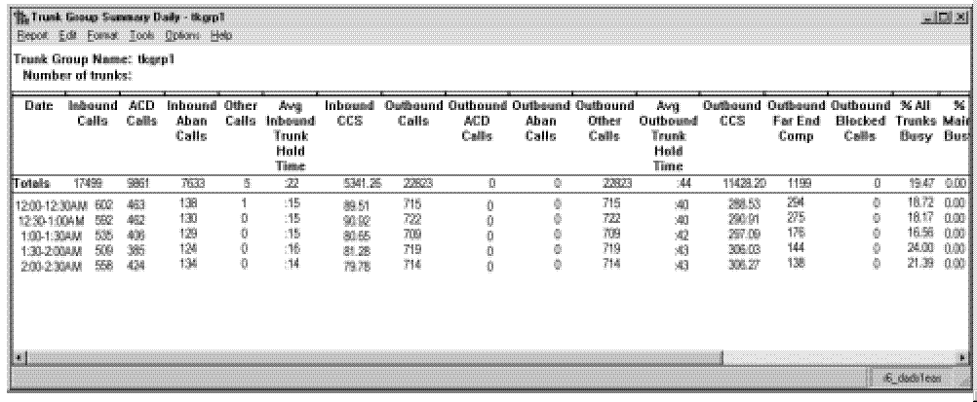

Historical VDN Reports

VDN Busy Hour
The VDN Busy Hour report shows call handling data for the busiest hour in the selected day for each selected VDN. The busiest hour is the set of contiguous intervals, totaling an hour, that had the highest number of incoming calls for the VDN. For example, if your system stores data in 15-minute intervals, the busiest hour might be the four intervals from 10:15 a.m. to 11:15 a.m. or the four intervals from 4:30 p.m. to 5:30 p.m.

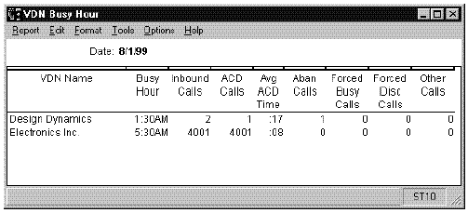

VDN Call Profile
The VDN Call Profile report displays the numbers of answered/connected and abandoned calls within each of the administered service level increments for the VDN during the selected time period. The VDN Call Profile report also displays the acceptable service level administered for the VDN and the percentage of calls completed during the reporting period that were answered/connected within that service level. Because this report shows you how long it takes for calls to be answered or abandoned, you can determine how long callers are willing to wait for agents before hanging up. With this information, you can determine the answering speed required to reduce the number of abandoned calls. Each of the ten columns represents a progressively longer wait time. For example, the first column shows calls answered/ connected in less than or equal to PERIOD1 seconds, the second column shows calls answered/connected in less than or equal to PERIOD2 seconds, but greater than PERIOD1 seconds, and so on. Calls receiving a forced busy or disconnect and calls that outflow (for example, routed to another VDN) are not considered in the VDN Call Profile report. The VDN Call Profile report is available in daily, weekly, and monthly versions.

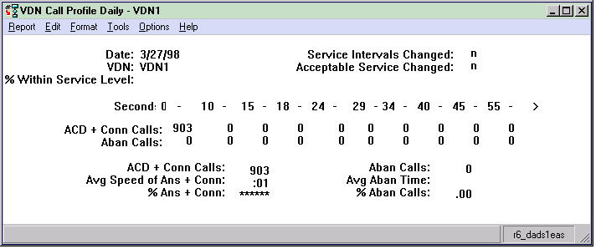

VDN Graphical Busy/Abandon/Disconnect Comparison
This report shows the percent of busy, abandon, and disconnect for summarized VDNs in one ACD for the date you specify. The selected ACD is displayed at the bottom right of the report. A legend on the right side of the report shows the color scheme for % Busy, % Abandon, and % Disconnect. % Busy refers to the percentage of the total calls that are busy for all VDNs on the ACD. % Abandon refers to the percentage of the total calls that abandoned for all VDNs on the ACD. Disconnect refers to the percentage of the total calls that are disconnected for all VDNs on the ACD.

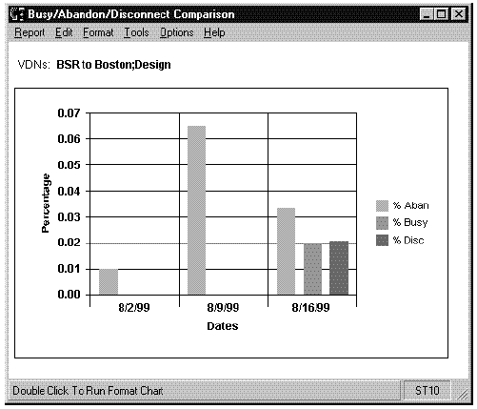

VDN Graphical Call Profile
This report shows how calls to the VDN you specify are being handled compared to your call center’s predefined Acceptable Service Level for the date you specify.
This report has four charts and displays a collection of VDN call profile related data items at the top of the report. The box to the right of each chart is a legend.
The three-dimensional pie chart in the upper-left quadrant shows the percentage of ACD calls answered within the predefined Acceptable Service Level and the percentage of ACD calls answered outside this level. The numerical value represented by each pie piece is shown inside the pie chart.
The stacked area graph in the lower-left quadrant shows the number of ACD calls answered and abandoned within each service level. Note that the number displayed for each service interval is the upper limit of the interval. (For example, if the first two intervals are "5" and "10," the first data point shows answers/abandons within 0-5 seconds, and the second data point shows answers/abandons within 6-10 seconds.)
The three-dimensional pie charts on the right side of the report show the Percentage Answered Distribution and the Percentage Abandoned Distribution. The numerical value represented by each pie piece is shown inside the pie chart.

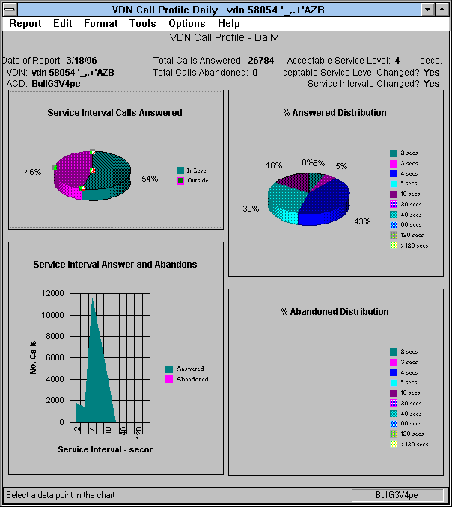

VDN Graphical Service Level
This report shows the percentage of ACD calls answered within the predefined Acceptable Service Level and the percentage of ACD calls abandoned for the date and VDN that you specify. Each set of vertical bars is labeled with the start time for the service interval.

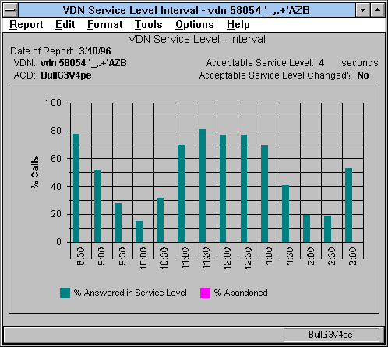

VDN Multi-ACD Flow
The VDN Multi-ACD Call Flow report shows call-handling data for the VDNs and the ACDs you select. This report can display information on up to eight ACDs. The VDN Flow Out report item includes only calls that route to another VDN and route to an external (off-switch) destination. The VDN Flow Interflow report item includes both Lookahead Interflow and non-Lookahead Interflow call completions. The VDN Multi-ACD Call Flow is available in daily, weekly, and monthly versions. You cannot customize this report.

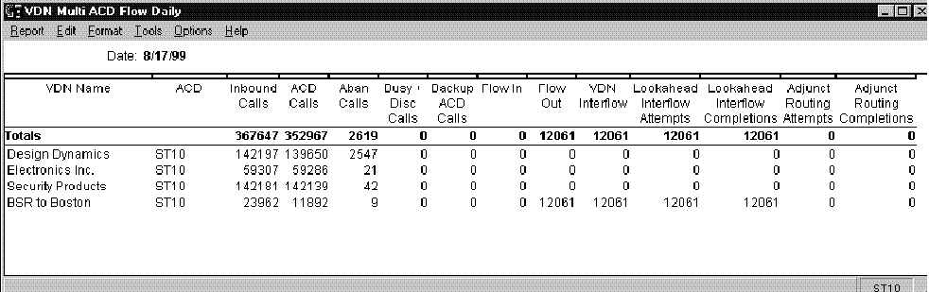

VDN Report
The VDN Report gives you historical information for a specified VDN and period of time. The interval, daily, weekly, and monthly VDN Reports display, for a particular VDN, various types of data that show how well calls to that VDN were handled. If you have Expert Agent Selection (EAS), the VDN report includes three VDN Skill Preference columns on the right-hand side of the report. The VDN Report is available in interval, daily, weekly, and monthly versions.

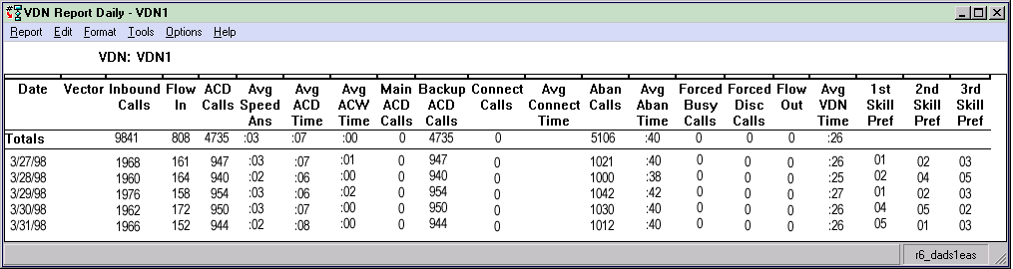

VDN Skill Preference
The VDN Skill Preference report shows the number of calls answered, average talk time, and average after call work time for calls to the VDN by skill preference for which they were answered. The report lists information for the first, second, and third VDN skill preferences. If the VDN skill preferences are referred to explicitly in the vector (for example, "queue to main skill xx" instead of "queue to main skill 1st"), the calls answered for that skill are included in this report. The VDN Skill Preference report is available in interval, daily, weekly, and monthly versions.

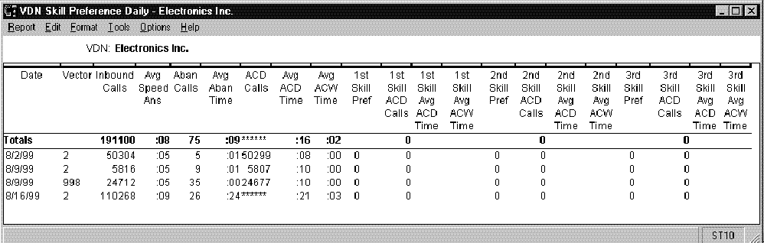

Historical Vector Reports

Vector Report
The Vector report displays, for a single vector, various types of data that show how calls were handled by the vector. This menu item is available only if you have purchased the Avaya CMS Vectoring feature and that feature has been authorized for you to use. The Vector report is available in interval, daily, weekly, and monthly versions.

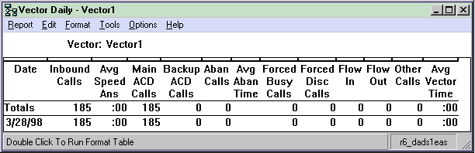

Integrated Reports
Integrated Reports, which are accessible through the CMS Supervisor interface, compile call center information from any starting point in the last 24 hours up to and including the current interval. At the Reports Integrated tab, reports that refresh in real-time can be selected to display information accumulated from any interval beginning in the past month, week, or day, until the time the report is generated. Standard integrated reports can show data for ACD, agent, split/skill, trunks/trunk group, vector, and VDN activities. The reports you see depend on your switch type, permissions, and system performance.
Integrated reports can be displayed on your PC, printed, stored to a file, copied to a clipboard, run as a script, or exported to HTML format through the Save as HTML feature.
The following diagram shows how the Integrated reporting system is structured. The sample reports provided immediately following the diagram are organized in the same order as outlined in the diagram.

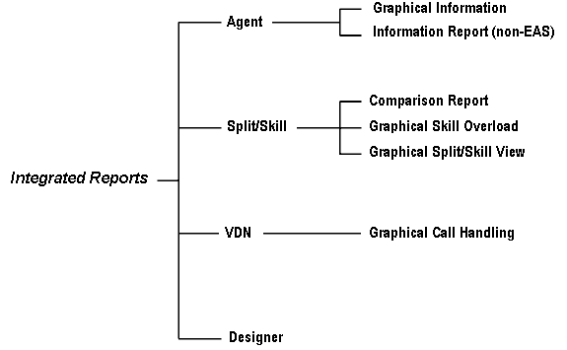

Agent Graphical Information Report
The Agent Graphical Information Report shows information and statistics for an agent from a specified interval start time, within the past 24 hours.
This report can be accessed in the following ways:
- From the Integrated Agent Category selector menu.
- By drilling down to this report from the Agent Name or Login ID fields on other reports (for example, Work State, Graphic AUX Agent reports or Call Center Administration windows).
Supervisors can use this report to access further information on one particular agent without having to execute several steps and several different reports to get the pertinent information. This report enables supervisors to quickly evaluate agent performance and decide whether an agent should be added to or removed from a skill.
The following list describes the information this report will contain:
- A two-dimensional bar chart shows the time the agent has spent in each of the work states since the report data start time. Above the bar chart is the text “Agent Time Spent.”
- A table show the skills assigned to the agent and the corresponding skill level. A scroll bar is provided if the number of skills to which the agent is assigned exceeds the default size of this table.

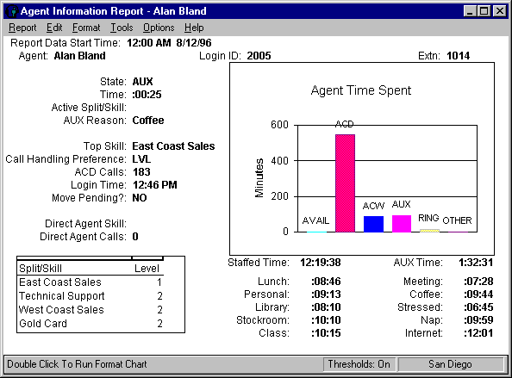

Agent Information Report
The Agent Information report shows information and statistics for an agent from a specified start time. This report is not available with the EAS feature.
This report can be accessed in the following ways:
- From the Integrated Agent Category selector menu.
- By drilling down to this report from the Agent Name or Login ID fields on other reports (for example, Agent Information, Work State, Graphic AUX Agent reports or from Call Center Administration windows).

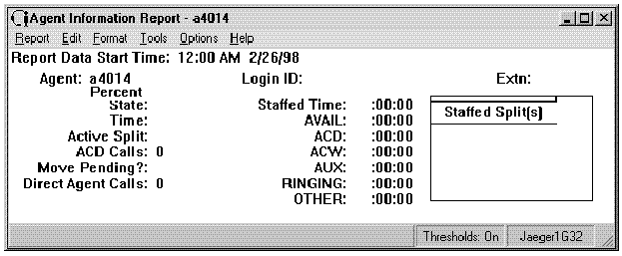

Split/Skill Comparison Report
This report shows the current status and cumulative data for one or more splits or skills. Call center supervisors or administrators who are responsible for several splits/skill can use this report to see if splits/skills have comparable talk times, abandon rates, and average speed of answer figures that are comparable up until a certain point in the day.

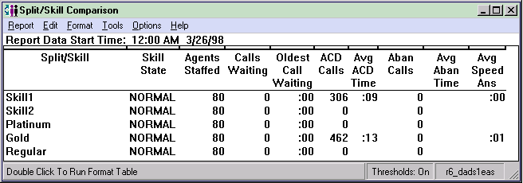

Graphical Skill Overload Report
This report shows the amount of time each specified skill has spent in normal versus overload conditions from the report start time until the report generation time since a specified start time in the last 24 hours. This report is available only if you have purchased the Expert Agent Select (EAS) feature. The Graphical Skill Overload report is a vertical bar graph.

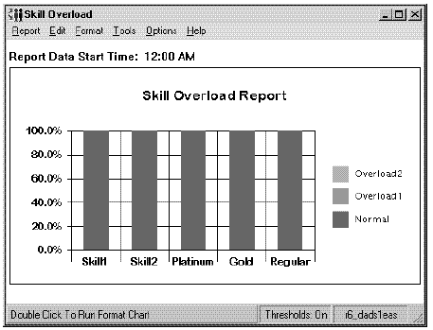

Graphical Split/Skill View Report
This report shows the status of agents in the split/skill and cumulative split/skill statistics. Call center managers can use this report for large numbers of agents in one split or skill, and need split/skill status but do not want to consume the PC resources required to display individual agent status of many agents. Call center managers can use this report to see the totals and averages for a specific split or skill up to a certain point in the day.

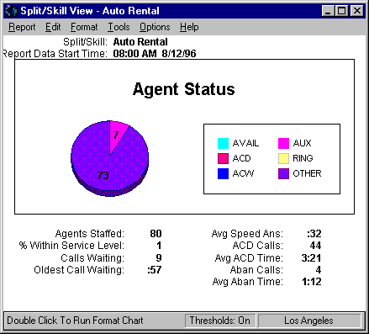

VDN Graphical Call Handling Report
This report shows, for each VDN, the cumulative number of calls that are answered, abandoned, and considered outflow calls. The report also includes the average speed of answer. This report shows in chart format how many ACD calls for each specified VDN were answered, abandoned, or outflowed. It also shows the switch-based ASA.
This report consists of two charts, with a legend to the right of each.
- The top chart is a three-dimensional, horizontal, color-coded bar chart showing the numbers of ACD calls answered, abandoned, and outflowed.
- The bottom chart is a line graph, where the Rolling ASA for each specified VDN is represented by each color-coded line.

