All New Enhanced Voice Messaging!
MailHub takes Unified enterprise messaging to a whole new level, delivering:
■ One-stop access to voice, email and fax messages
■ Built-in synchronization between the Avaya Voice Mail and your Email System

Experience the Benefits of MailHub
■ Adaptability: Works with ALL email systems
■ Simplicity: No desktop software to deploy or support
■ Productivity: Significantly reduces amount of time spent processing voicemail.
■ Mobility: Easy access to all of your messages from any device with Internet access
■ Affordability: Pays for itself with reduced phone and related port usage as well as increased productivity

Starting @ $2500 with Server

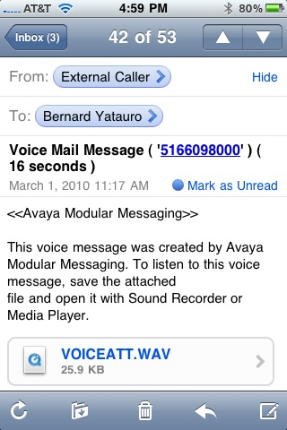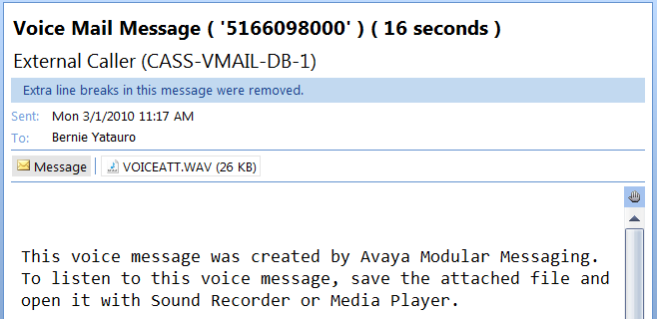

IA770 INTUITY™ AUDIX® Messaging Application
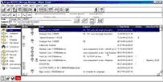
The Avaya INTUITY™ AUDIX® 770 (IA770) Messaging Application is a powerful addition to Avaya Communication Manager-based IP Telephony solutions for the mid-market. The IA770 application delivers voice, and text messaging to help improve communications and simplify information exchange within enterprises. IA770 is co-resident with Communication Manager on the S8300 and S8400 Media Servers.
The IA770 solution provides call answering and messaging capabilities on the Avaya S8300 and S8400 Media Servers running Avaya Communication Manager software. It enables users to manage messages on their PCs (through the INTUITY™ Message Manager visual desktop client), add a voice mail component to a text message, and listen to text messages via telephone. The IA770 application is ideal for small to mid-size businesses and small locations of large enterprise customers who need a standalone messaging application embedded in their IP communication systems.
IA770 is offered on the S8300 Media Server which works with the G250, G350, or G700 Media Gateways, or on the S8400 Media Server which works with the G650 Media Gateway. Capacities vary depending on which server and gateway are used.
The IA770 application supports 35 languages. The IA770 Messaging Application supports the TCP/IP networking protocol. More extensive networking can be provided through the Avaya Message Networking solution. IP integration is via H.323 and T.38 protocols.
S8300/G250 supports up to 12 seats and 3 ports (1 reserved for MWI/transfer)
S8300/G350 supports up to 100 seats and 6 ports (2 reserved for MWI/transfer)
S8300/G700 supports up to 450 seats and 12 ports (4 reserved for MWI/transfer), and S8400/G650 supports up to 450 seats and 12 ports (4 reserved for MWI/transfer)

